MIDLANDS STATE UNIVERSITY

FACULTY OF COMMERCE

BUSINESS SCHOOL OF LEADERSHIP

THE USE OF INFORMATION AND COMMUNICATION TECHNOLOGY IN THE PERFORMANCE OF MINISTRIES: A CASE OF PUBLIC SECTOR OF ZIMBABWE

BY
PHYLLIA MASHUMBA
R12703G

SUBMITTED TO THE MIDLANDS STATE UNIVERSITY IN PARTIAL FULFILMENT OF THE REQUIREMENTS FOR MASTERS IN BUSINESS ADMINISTRATION
(MBA)

NOVEMBER: 2013
GWERU, ZIMBABWE

MIDLANDS STATE UNIVERSITY
RELEASE FORM

NAME OF AUTHOR: PHYLLIA MASHUMBA

TITLE OF PROJECT: The use of Information and Communication Technology in the performance of Ministries: A case of Public Sector of Zimbabwe

PROGRAMME: MASTERS IN BUSINESS ADMINISTRATION

YEAR GRATED: 2013

Permission is hereby grated to the Midlands State University Library to produce single copies of this project and to lend or sell such copies for private, scholarly or scientific research purposes only. The author reserves other publication rights and neither the project nor extensive extracts from it may be printed or otherwise reproduced without the author’s written permission.

SIGNED: ………………………………………………………………….

PERMANENT ADDRESS: 14248/6
Kuwadzana Extension
Harare

DATE: NOVEMBER 2013

MIDLANDS STATE UNIVERSITY
APPROVAL FORM

The undersigned certify that they have read and recommend to the Midlands State University for acceptance: a dissertation entitled The use of Information and Communication Technology in the performance of Ministries :A case of Public Sector of Zimbabwe submitted by Phyllia Mashumba in partial fulfilment of the requirements for the degree of Masters in Business Administration (MBA)

………………………………………………………………..
SUPERVISOR

………………………………………………………………
PROGRAMME/SUBJECT COORDINATOR

……………………………………………………………..
EXTERNAL EXAMINER

…………………………………………………
DATE

DEDICATION

This dissertation is lovingly dedicated to my respective parents and my two angels Tendai and Tanaka Chiremba who have been my constant source of inspiration. My parents have given me the drive and discipline to tackle any task with enthusiasm and determination. Without their love and support this research paper would not have been made possible.

God bless you all

ACKNOWLEDGEMENTS
I wish to acknowledge the assistance from various players in Government, who took their valuable time to assist me in the dissertation from the start to the final production of the project document.
Special thanks go to my Supervisor, Ms P. Siwadi, whose encouragement, meticulous revision, sage advice, insightful criticisms, patient encouragement, guidance and support from the initial to the final level enabled me to develop an understanding of the subject.
I would also like to thank my employer for funding the whole programme.

ABSTRACT

The purpose of the research was to make a survey of the use of Information and Communication Technology in the performance of ministries in the Public Sector of Zimbabwe with specific reference to the 5 selected Ministries .The backgrounds reviewed up to the global level of ICT. The proliferation of ICT indicates a low average due to insuffient budgets. The availability of ICT in ministries is not improving the performance of Ministries. There is lack of management support which result in low literacy rate in which the respondents indicated that the funds are not adequate and the selection criteria is not fair on training. There should be control and protection of Public secrets by harnessing ICT security. The study further included an exploratory quantitative component where a sample of fifty employees was selected to complete the questionnaires, 10 questionnaires were distributed to 10 heads of sections in Ministries. The recommendations made included the need to have an effective Management of Information Systems and training of staff, full support from management is needed in all areas including budget and this will result in the protection of the Nation secrets and keep Zimbabwe abreast in Technology.

TABLE OF CONTENTS
ITEM PAGE
Cover page i
Release Form ii
Approval Form iii
Dedication iv
Acknowledgements v
Abstract vi
Table of Contents vii
List of Tables x
List of Figures xi
List of Appendices xiii
CHAPTER 1......................................................................................................................................1
1.1Introduction.......................................................................................................................1
1.2 Background of the study 1
1.3 Problem Statement 7
1.4. Research Objectives 7
1.5 Research Questions 8
1.6 Significance of the Study 8
1.7 Delimitation 9
1.8 Theoretical/Conceptual framework 10
1.9 Limitations 11
1.10 Definition of terms 11
1.11 Chapter Summary 13

CHAPTER TWO
2.0 Introduction 14
2.1 The Proliferation of Information and Communication Tools..............................14
2.1.1 ICT Proliferation Environment 17
2.1.2 ICT Budget 19
2.1.3 Global aspects of ICT proliferation 20
2.1.4 ICT Infrastructure and Proliferation 22
2.3 To isolate the role of ICT in the performance of Ministries 22
2.2.1 Role of ICT for Organisational Development 23
2.2.2 Definition of Information and Communication Technology 24
2.2.3 Definition of Management of Information Systems 24
2.2.4 ICT and Performance of an Organisation 26
2.2.5 E-readiness and ICT role for Development 27
2.2.6 Database Management Systems in ICT Usage 27
2.3 ICT Literacy for Capacity Building……………………………………………28
2.2.1 ICT Literacy Impact……………………………………………………………28
2.3.2 ICT Training Skills…………………………………………………………….29
2.3.3 Global view on ICT Literacy 30
2.4 ICT Security Issues and ICT National Policy 31
2.4.1 ICT Security 31
2.4.2 National ICT Policy Framework 32
2.4.3 International ICT Policies 33
2. 4. 4. I CT Security of Information Systems 34
2.5. Conclusion 35

CHAPTER 3
3.0 Introduction 36
3.1. Research design 36
3.2. Population 38
3.3 Sampling 38
3.4 Respondent selection 39
3.5 Research instrument used 39
3.6 Advantages of a questionnaire 41
3.7 Documentary search and Desk Study 41
3.8 Validity and reliability of data 41
3.9 Validity of data 41
3.10 Reliability of data……………………………………………………………………………………………………………….42
3.11 Pre-testing 42
3.12 Data analysis 42
3.13 Summary 43

CHAPTER FOUR.......................................................................................................................... 44
4.0. Introduction 44
4.1 Data presentation process 44
4.2 Proliferation of ICT in the Public Sector 47
4.2.1 Level of ICT Usage in Ministries 48
4.2.2 ICT Hardware used in Ministries 49
4.2.3 Application Software in Government Ministries 51
4.2.4 Role of ICT upgrading issues 52
4.3 Objective 2: Role of ICT in the performance of Ministries 54
4.3.1 Transaction Cost and Time Assistance Comparison with Budget and ICT Usage in Ministries 56
4.3.2 How Complains and Backlogs assist comparing to the availability of Networks and Hardware in Ministries for Ministries Performance 57
4.3.3 How ICT assist in decision making and queues comparing with availability of hardware, and ICT usage in the performance of Ministries 58
4.3.4 A comparison of how ICT assist documentation and Records retrieval and the availability of application software, literacy and management support in Ministries 59
4.3.5 Time when Ministry Plans to cooperate with other Ministries (n=50) 60
4.3.6 Extent of Impact Barriers have on ICTs (n=50) 61
4.3.7 ICT Functions handled by External Suppliers or Own Ministry Staff (n=50) 61
4.4 Objective 3: ICTS literacy in the public sector for capacity building and organizational performance 62
4.4.1 Hindrance to Computer Use by Government employees (n=50) 63
4.5 Objective 4: Security measures of ICT in the Public Sector in Collaboration with ICT National policy 64
4.5.1 Rating of Management Support in terms of ICT 65
4.5.2 Rating of controls 65
4.5.3 Chapter Summary 67
CHAPTER 5………………………………………………………………………………. 68
SUMMARY, CONCLUSIONS AND RECOMMENDATIONS ……………………………………..68
5.1. SUMMARY 68
5.2 CONCLUSIONS 69
5.2.1 Objective 1: ICT proliferation in Government Ministries and Departments in the context of public sector performance ……………………………..69
5.2.2 The role of ICT in the performance ofMinistries…………………………..70
5.2.2.1 Recommendations………………………………………………………….70
5.2.3 Objective 3: ICTs literacy in the public sector for capacity building and Organisational performance 71
5.2.3.1 Recommendations…………………………………………………………….71
5.2.4 Objective 4: ICT Security measures in the Public Sector in collaboration with the ICT National policy……………………………………………………. 72
5.2.4.4 Recommendations………………………………………………...…………..72
References……………………………………………………………………………….73

LIST OF TABLES
ITEM PAGE
1. Table 1.1: Current ICT Systems and applications used in Ministries…… …………………2
Table 1.3 Zimbabwe Contribution to GDP……………………………………………………4
Table 1.5 ICT Penetration in Zimbabwe……………………………………………………...5
2. Table 4.1: Questionnaire response ………………………………………………………..44
3. Table 4.3: Personal Data response ………………………………………………………..45

LIST OF FIGURES
ITEM PAGE
1. Figure 1.2: Global ICT development………………………………………………………4
2. Figure 1.3: Zimbabwe contributing to GDP 2011 by sector ………………………………4
3. Figure 1.4: ICT Penetration rights in Zimbabwe…………………………………………..5
4. Figure 1.5: ICT usage in Zimbabwean Ministries…………………………………………5
5. Figure 1.6: Applications targeted for implementation…………………………………….6
6. Figure 1.7:ICT diffusion of Theory……………………………………………………….10
7. Figure 2.1: Literature review process……………………………………………………..15
8. Figure 2.2: Typical computer system……………………………………………………..25
9. Figure 2.3: ICT systems readiness in Zimbabwe…………………………………………26
10. Figure 2.4:RBM framework and linkages……………………………………………..…27
11. Figure 2.5: Building a structure plan……………………………………………………..35
12. Figure 3.1: Approaches to research……………………………………………..…….….37
13. Figure 3.2: Population sample……………………………………………………………38
14. Figure 4.2: Respondent segmentation…………………………………………………....46
15. Figure 4.4: Respondents……………………………………………………………….....46
16. Figure 4.5: Distribution of respondents by education……………….…………………...46
17. Figure 4.5: Level of ICT budget in Ministries………………………………………..….47
18. Figure 4.7: Networking system availability and type in Ministries……….…………….49
19. Figure 4.8: Systems used in Government Ministries…………………………………...50
20. Figure 4.9: Application software…………………………………………………..…….51
21. Figure 4.10: Views on extent ICTs are well maintained and updated…………………53
22. Figure 4.3.1: Transaction time and transaction cost………………………………..…….54
23. Figure 4.3.2: Complains and backlogs…………………………………………………...54
24. Figure 4.3.3: Decision making and queries…………………………………………...….55
25. Figure 4.3.4: Documentary and records retrieval………………………………………...55
26. Figure 4.11: Transaction cost and time comparison……………………………………...56
27. Figure 4.12: Complaints and backlogs comparison……………………………………...57
28. Figure 4.13: Decision making and questions comparison…………………………...…..58
29. Figure 4.14: Documentation and records retrieval comparison………………………….59
30. Figure 4.15: Role of ICT in job execution……………………………………………….60
31. Figure 4.16: Training on ICT knowledge……………………………………………...…62
32. Figure 4.17: Knowledge of ICT………………………………………………………….63
33. Figure 4.18: Level of benefits…………………………...……………………………….64
34. Figure 4.19: Frequency of ministry updates on ICT policy documents………………….64
35. Figure 4.20: Rating of controls……………………………………………..……………66
36. Figure 4.21: Rating of management structure……………………………………………66
37. Figure 4.22: Rating of software awareness……………………………...……………….66

LIST OF APPENDICES
- Appendix 1: Research questionnaire………………………………………………….. 80

CHAPTER 1

1.1 Introduction

This is an introductory chapter for the dissertation based on the use of Information and Communication Technology in the performance of ministries: A case of Public Sector of Zimbabwe. The current status of ICT tools, their uses and their impact on organisational performance and why the Government has embraced the arrival of ICT. The chapter further provides the problem statement, research objectives, research questions, significance of the study, delimitation, theoretical framework, limitations, definition of terms and chapter summary.

1.2 Background of the study

The world over, ICT is no longer considered a luxury but an essential tool for achieving sustainable development. In line with this, Kundishora (2012) suggests that government must undergo internal and external transformation in order to move in unison with the private sector and respond swiftly to ICT developments. This would dictate, therefore, that the development of ICTs in government organisations will be for national benefit. In response to this, the Ministry of Information Communication Technology was set up by the Government of Zimbabwe in 2009 whose main purpose was to develop appropriate policies and regulatory frameworks as well as promote ICT Literacy. In addition, the Ministry seeks to create a conducive environment for ICT investment through public-private partnerships, national ICT research and development of software, hardware and infrastructure as well as strategies that enhance provision of information communication technology innovations for national building. The Ministry of Information Communication and Technology dream is to turnaround Zimbabwe to be a knowledge based society with connectivity by the year 2015.MICT (2012).

The Government of Zimbabwe and civil society organizations have demonstrated an enthusiasm and positive attitude in promoting ICTs for development in general and in Government operations for ministries performance in particular. The promotion of ICT has seen many Ministries and Department become modernised, the diagram below summaries some of the developments in ICT systems and databases used for organisational performance. Civil Service Commission e-Government survey Report (2012).
Table 1.1 Current ICT Systems and applications used in Ministries and Departments
ICTs used in Government Ministries | Use for Government operations and Performance
Word processing | Write letters, reports, speeches
Spreadsheets | Analyze financial information, calculations
Database Software | Customer contacts, catalogues, records management
Presentation software | Presentations, publish in digital format via email
Desktop Publishing | Produce newsletters, magazines
Graphics software | Edit images, drawings, websites
Accounting package | Revenues, sales, purchase, bank accounts ,PFMS,SAP(Ministry of Finance and Ministries Accounts Section)
Computer Aided Design | CAD programs, engineering, architectural, electronics Road ways( Ministry of Local Government, Public Works)
Customer Relations Management(CRM) | Product preferences, buying habits
Internet/online websites | Communication, disclosure and research
Landlines, Cellphones | communication

Sources: Central Computing Services and Government Internet Service Provider Zimbabwe 2012

Government Ministries have developed ICT applications and systems for effective management and operations with the hand of Ministry of Information Communication and Technology, GISP, Central Computing services, Ministry of Science and Technology, SIRDC. Accounting packages are being used for effective accountability with all ministries and the Ministry of Finance manages the databases like the PFMS and SAP. Word processing applications are being used across the ministries for standard professionalism and effective management in the public sector. Database softwares are being used for records management systems in Registries and especially the Registrar General Office and other ministries which deal with the public for effective service provider. Kundishora (2012)

The Civil Service Commission Reforms report (2009) alludes to the fact that the Government of Zimbabwe, since 1980 has been involved in a number of initiatives to modernize government operations and has actively implemented a series of reforms Following a series of public complaints concerning the unsatisfactory performance of the public service in areas of service delivery and accountability, Munyaradzi (2012) states that the cabinet has harnessed the use of information technology for improved Ministry performance. Above all this, the Government has the perception that Zimbabwe will be transformed to an IT knowledge based society to enhance overall economic competitiveness, and economic growth through the use of these ICTs information communication technology for ministries performance (MICT Strategic Plan, 2010-2014). Thus, the Government acknowledges that access to information and communication technology (ICT) in Government ministries has become an indispensable part of the world economy, may provide vast opportunities for every Government employee and every citizen to participate in socio-economic activities. This may also lead to an improvement on the access to markets, jobs, business, education and training. With better ICT infrastructure, Government ministries will have the potential for innovation, economic development and better public service delivery in the country. The main reason for this increased focus on ICTs can also be attributed to their significant impact on the GDP of the country as evidenced in Tables below.

Figure 1.2: Global ICT development
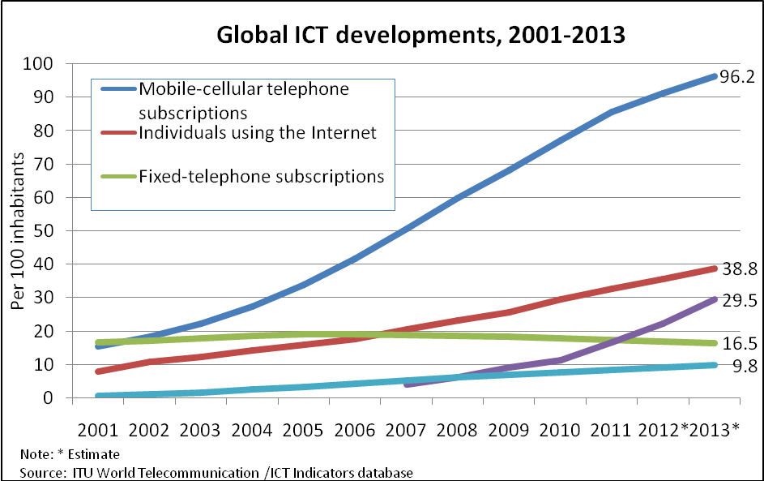
Source: International Technology Union 2013 database Indicator
However, the latest ICT development index published by the International Telecommunications Union (2012) plotted out that there is a great move in terms of information and communication technology access and usage in nation. The above Figure 2 illustrates the growth rate of ICT usage in Africa.

Table 1. 3: Zimbabwe Contribution to GDP 2011 by Sector
Industry | % GDP
Agriculture | 15.5
Information and Communications Technology | 15.2
Manufacturing | 14.7
Other services | 4.3
Source: 2013 National Budget Report

According to the National budget report , it stated that ICT contributed a positive percentage of 15.2% to the national economy as compared to other sectors hence this sums the impetus role of ICT for national building

Table 1.4 ICT Penetration rates in Zimbabwe

 | ICT Penetration Rate
Mobile | 13%
Internet | 15%
Fixed Telephony | 3%
Source: www,techzim.co.zw
POTRAZ 2012 quarter Statistics

Table 1.4 above shows the low penetration rates of ICT in Zimbabwe as measured across the three main sources of ICT. The rather low ICT adoption rates in Zimbabwe are not only a private sector problem but also reflect in the public sector. Figure 1.5 below shows the current usage of ICTs in Government Ministries showing the growth as from 2009 to 2012.
Figure 1.5 ICT usages in Zimbabwe Ministries

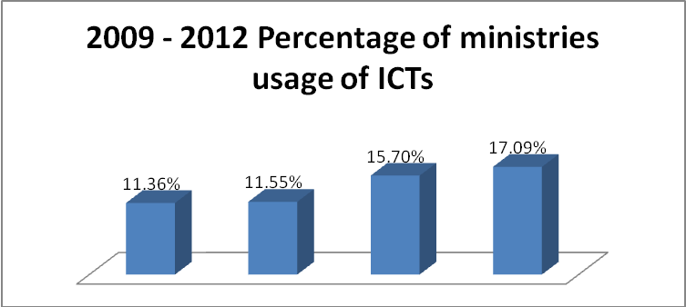
Source: Civil Service Commission e-Government report 2012

Therefore, the Zimbabwe Results Based Management Progress report (2012) reported that in attempting to improve ICT development in Zimbabwe, Government is strengthening prioritization of public spending and improving value for money through ongoing implementation of Information Technology efficiency measures which aim to link public spending more closely to outputs like computerized Results based management budgeting systems and monitored information management systems including computerized records. In this regard, Government introduced computerized performance contracts for Heads of Ministries in 2011 aimed at ensuring accountability, transparency and focus on critical results that improve the social and material conditions of citizens they serve and for the effective performance of Government Ministries. Furthermore, the Minister of Finance harnessed the intervention of e-Government applications. The main purpose is, thus, to improve efficiency in the delivery of public services, increase revenue generation to the fiscus as well as stimulate economic growth. In addition, Figure 1.6 below shows e-applications budget estimates.
Figure 1.6: 2013 E-applications targeted for implementation to improve efficiency in the
Delivery of public services

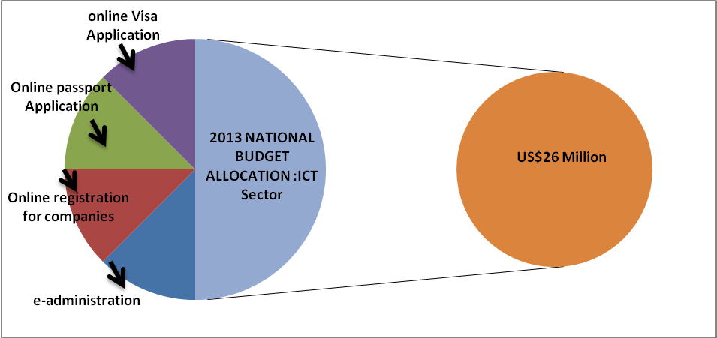
Data Source: 2013 Zimbabwe National Budget Statement

However, despite all these Government efforts, one fundamental problem that arises is that these tools are being used on the perception of effective performance of Government Ministries. Civil Service Commission reforms report (2009). In comparison with information technology in other countries, there seems to be misuse of information and communication technology tools in Government Ministries that deals with the public for example Registrar General. It becomes essential to establish the impact of ICT for Government performance because the use of information technology in ministries is quite critical to the Public Sector so as to to improve services to citizens. Well managed information technology systems provide strong foundation for enhancing accountability, transparency, democratic governance, poverty eradication, and elimination of corruption as well as efficient use of donor funded resources in the Public sector. Munyaradzi (2012)

Out of 26 ministries, three quarters of ministries have installed ICTs in their sections but the question is “Is the information technology improving the performance of service delivery or it is just being for the benefits of employees to do their personal businesses?” Hence the use of information technology can have many anticipated negative side effects such as lost productivity while employees waste time retrieving personal information. The other issue is that surfing the internet at that very high rate cost a lot of money as well as telephone calls. Given the scenario above, Information Technology has become two faced, it produced knowledgeable and skillful workforce, but on the other side decays the social system of the environment it touches thereby affecting the performance of Government ministries.

1.3 Problem Statement
The literature discussed above shows that there are significant benefits of using ICT for organisational performance. In addition, there has been some work done by Government in implementing ICT in various departments. However, there is still a problem in that ICT adoption and penetration is still very low in Zimbabwe and more so in the public sector. On the other hand, Government employees have different perceptions and attitudes towards the use of ICTs in their workplaces with some viewing Information technology as more of entertaining tools than working tools which hinders the performance of ICT in achieving positive organisation outcomes. The study will therefore seek to evaluate the extent to which ICTs has affected the operations of Government Ministries and Departments and shed light on whether ICT is a prescription for Public Sector performance and development.

1.4. Research Objectives
(i) To measure ICTs literacy in the public sector for capacity building and Organisational performance to keep Zimbabwe abreast with technology

- To assess the proliferation of Information Communication Technologies (ICTs) in Government Ministries and Departments in the context of public sector performance
- To isolate the role of ICT in the performance of Ministries
- To identify security measures of ICTS in the Public sector in collaboration with the ICT National policy for the preservation of National secrets

  - Research Questions
- Are there any procedures and factors mitigating the proliferation of Information Communication Technologies (ICTs) for Zimbabwe in the context of public sector performance?
- What is the role of ICT in the performance of Ministries?
- Are the public sector employees well trained in the use of ICTs for capacity building and Organisational performance?
- Are there any security measures of ICTS in the Public sector in collaboration with the ICT National policy?

  - Significance of the Study

The results of the dissertation would be vital to Government Ministries and Departments of all nations, Treasury, legislators and the general public that deals with service delivery in any country.

To the student, more knowledge will be gained from the findings of the research. The research may also assist the university’s current and future students understand information technology and performance in Government Ministries in the public sector of any given country

There have been so many complaints and concerns raised about the loss of time and employee productivity as Government employees chat on the telephone or surf the Internet during working hours and abusing ICT tools. The other worry is that when Government employees use the organisation’s e-mail, everything they do including anything illegal, carries the organisation’s name and wasting of Government finance especially this era of Results based management system. While there are many views regarding the negative effects of the Internet in general, not much has been done to explore the abuse of ICTs at the workplace especially with reference to public sector performance. Therefore the study will also create a platform for exploring if the Government employees are aware of why ICTs are installed at their workplaces and also coming up with effective measures to deal with the abuse.

Literature which narrates the use of Information and Communication Technology for organizational performance are looked at like the ICT Study materials. The research will establish useful information management tools ideal to the public sector. As a step towards ICT development in Zimbabwe it is a return measure aimed at enhancing integrity and professionalism ensuring transparency crafting a culture of high performance and enhancing citizen confidence in the public sector. The research will be part of the body of literature concerning Information and Communication Technology and performance in the Public Sector of Zimbabwe because it unearths the use of information technology in the performance of ministries.

  - Delimitation
The research would be confined to an analysis of the use of information and communication technology in the performance of (5) government ministries head offices in Harare from 2005-2013. These are Ministry of Finance, Ministry of Media and Broadcasting Services, Higher and Tertiary Education, Ministry of Primary and secondary Education, and Ministry of Information and Communication Technology. The rest of the civil service countrywide would be excluded though the results would be inferred against the whole population. The study will cover the use of information and communication technology for ministries performance from the time the ministry was networked. The study would also focus on what the ministries have done so far in managing its management information systems and ICTs.

  - Theoretical/Conceptual framework
A conceptual framework is “a set of coherent ideas or concepts organized in a manner that makes them easy to communicate to others [it is] an organized way of thinking about how and why a project takes place, and about how we understand its activities”. [http://www.lazogroup.ca/msproject/framework1-e.php]. A framework helps to explain why a study is taking a particular direction. Ain this study the diffusion theory is ideal because it also helps to foreground concepts/ideas/theories that are key to understanding the study directions of ICT. This study in particular focuses on the use of information and communication technology for ministries performance hence the need to understand the theoretical underpinnings.

Innovativeness in Government ministries is dependent on the employees’ leadership characteristics including the vision and commitment that influences Government employees to adopt new ICTs, the internal characteristics comprises of how the leaders control. The complexity in Government ministries that is the ICT knowledge and skills the employees possess and the degree to which Government employees follow rules and procedures. The degree to which ministries and departments are linked is also shown by interconnectedness and lastly the ministries slack in which uncommitted resources are available to the economy of Zimbabwe. The external characteristics of ministries demonstrate the openness of systems being used in ministries.
Figure 1.7
Ministries Leadership and Employees
Attitude towards change

The internal characteristics of Ministries and Departments Structure
Centralisation, Complexity, Formalization, Interconnectedness, Ministries and Departments slack size

Ministries and Departments Innovativeness

The external Characteristics of ministries and Departments
Computerised systems openness

Source: Researchers own creation
ICT diffusion of theory in Ministries and Departments
The role of Information Communication Technology has been widely documented by authors like Haag, Cummings and Dawkins (2008) stating that ICT is an essential enabler of innovation and a tool for getting the right information into the hands of the right people at the right time. ICT has become the key competitive tool for all organisations performance. The authors further define ICT as any tool that people use to work with information and support the information processing needs of an organisation. ICT encompasses any medium to record information for example flash disk and CD or DVD, technology for broadcasting information for example the radio and television, technology for communication such as telephone, cell phone and loudspeaker, computer hardware for example servers and all networked storage and all soft wares needed to operate network for transmission of information, for example the internet (Loudon, 2008).

1.9 Limitations

Shortage of funds may also affect the research. The information shall be sought from the managers and they mighty be busy to the extent that they may not want to give answers. Also some of the information shall be considered as secret by management henceforth they might be unwilling to provide the information.Resistance from other members who should participate to provide reliable information since the researcher is in the same organization that is the Public sector due to fear of victimization. Lack of participation by other members of staff since they may not take the researcher seriously on the study. Interference of the research process with productive time. The researcher being a female employee may face gender resistance where some members of the private sector may refuse to give valuable information to produce a quality report.

1.10 Definition of terms

Information and Communication Technology (ICT) - it is the use of computers, telecommunication office systems and technologies for the collection, processing, storing, packaging and dissemination of information.
Computer - an electronic device or machine used to process data into information
Data - unprocessed information
Database - Organized pool of data
Data files - Data files are created in database software programs and are therefore often represented proprietary formats
Digital - Information that relies on binary numeric (0-1)
E-mail - Electronic mail or an application that enables users to send and receive messages.
E-record - an item of information captured on an electronic medium
E- Records management - The scientific and systematic use of electronic records from point of creation to ultimate disposition.
Extranets - private network application linking an organisation’s office with external clients
File server - A powerful computer that contains programs and data which may be accessed by computers linked to it.
Firewall - A feature that protects a network connected to the internet from unauthorized users
Hacker - A person who explores computer systems and programs to the point of obsession
Hardware - Physical components of a computer
Hypertext Mark-up Language - (HTML) is used to display most of the information on the World Wide Web
IM - Information Management
Internet - The world’s largest collection of networks
Intranets - An internal corporate website
Information - Processed data. Meaningful data
Media - Material on which records are recorded on and stored
E-commerce - business activities involving consumers, manufacturers, suppliers, service providers and intermediaries using computer networks such as the Internet.
e-readiness - access to technology infrastructure, the degree to which e-business is being adopted by the Government and cultural conditions that influence use of ICTs
Network - An interconnection of information technology equipment
Record - information captured on a media
Server - A computer connected to a network that offers various services
System - An integrated assembly of electronic hardware and software
Virus - A small program commonly embedded in another program
Results based Management System (RBM) – contemporary and integrated management philosophy that focuses on the appropriate and timely achievement of set, planned or desired goals and objectives
Performance – the systematic assessment of the individual with respect to his performance on the job and potential for development and organizations
Impact- follow-up through consequence of one or more outcomes from an activity and outputs
Public Sector - portion of society controlled by national, state or provincial, and local governments
MICT- Ministry of Information and Communication
SAZ-Standards association of Zimbabwe
ZIMRA-Zimbabwe Revenue Authority

1.11 Chapter Summary
The chapter gave the background to the study highlighting the use of information and communication technology on the performance of ministries and departments. The statement of the problem acknowledges the challenges, the research objectives, research questions, significance of the study, delimitation, conceptual framework, limitation and definitions of terms have been explained clearly. The research aimed to come up with solutions on how information and communication technology can harness Government Ministries and Departments performance in the public sector. The rest of all chapters will answer the research questions of the study. The Next Chapter presents the Literature review based on the highlighted research objectives.

CHAPTER TWO

REVIEW OF RELATED LITERATURE

- INTRODUCTION

The purpose of this chapter is to give a detailed examination of existing literature, and to set out the definition and general conceptual framework of Information and Communication Technology (ICT) for organisational development. The chapter also seeks to discover the positive and negative impact of ICT on the Public Sector performance. Experiences of the Government of Zimbabwe Ministries and Departments in relation to available literature will also be used with a view of establishing the relevance of ICT as a developmental tool. This literature review therefore has two aims, firstly to review competing debates relevant to the use of the ICTs and their impact on Organisational development, secondly to bridge the gap by linking the theories on ICT to Organisational Performance approach and their relevance at the workplace.

The study is organized into four main themes namely the proliferation of Information Communication Technologies (ICTs) in Government Ministries and Departments in the context of public sector performance, isolate the role of ICT in the performance of Ministries, measure ICTs literacy in the public sector for capacity building and Organisational performance and finally the security measures of ICTS in the Public sector in collaboration with the ICT National policy. A brief overview of the available literature on Public Sector of Zimbabwe will also be presented. Below reflects the literature review process undertaken for this study by Muchi and McEvoy (2009).

The Literature Review Process
Figure 2.1
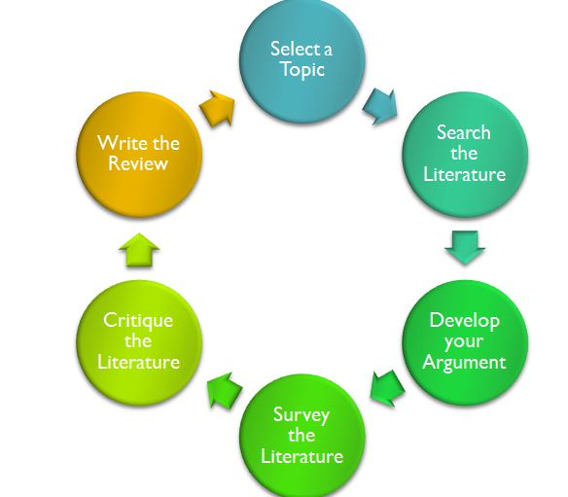
(From The Literature Review (2009) by Machi and McEvoy)
http://guides.library.unt.edu/content.php?pid=373248&sid=3057366

  - The Proliferation of Information and Communication Tools

This section covers the ICT proliferation environment, the ICT Budget, Global aspects of ICT proliferation and ICT Infrastructure and Proliferation.

2.1.1 ICT Proliferation Environment

Previous research have reported that the proliferation of Information Communication Technologies (ICTs) in developing countries has greatly improved the manner in which information is transmitted in that the ICTs have added speed and efficiency in information dissemination in Government processes and operations as investigated by Gogo (2012) in his published article. However recent evidence across the globe as of the investigations by Smith (2007) who agrees with Gogo (2012) and argued that the proliferation of ICT technologies did have a positive impact on various research domains and Government operations such as medicine, sociology, mathematics, business, research and development as what(Smith 2007). Stated as well.

The proliferation aspect in SriLanka as commented by the Green tech Consultants (2011) the survey they carried out find out that there should be the establishment of ICT Units in government organizations where such Units do not yet exist in that they will be responsible for ICT proliferation. Green Tech Consultants (2011) further investigated that government organizations should take steps to increase the networking of PCs which are presently functioning as standalone machines and move towards more usage of WAN to enhance the flow of ICTs in organisations. The findings of the SriLanka ICT proliferation situation it emphases the notion that Government organizations should ensure availability of adequate funds for the purchase of licensed software and hardware. On the analysis, it shows the emphasis of the Government to take steps to replace unlicensed copies of software in use with licensed copies and usage of unlicensed copies of Software among all organizations (particularly in individual PCs and laptops) and availability of hardware to improve service delivery and performance of Organisations

Commenting on the Zimbabwe situation, Kundishora (2013) in early 2013 in his seminal article reported that increase in ICT penetration rate in Zimbabwe is being caused by, the Government which is facing numerous challenges ranging from limited funding and inadequate communications infrastructure. However from the observation by the ICT Engineer of Zimbabwe, to overcome the challenges in the ICT proliferation aspect there is the need for the public and private sectors to come up with a well focused approach in addressing the issues at a broader level. There must be connectivity with other developed countries for technological developments.

Beqiri (2008) claims that Information and Communication Technologies (ICT) provide benefits to many Governments across the nation as in Japan in which the proliferation of ICTs and their decline are being affected by security issues such as lack of security awareness and training, operating system design and security, open source issues, design complexity and multiple layer approach. Therefore from the analysis above it is much critical for Governments to consider designing better operating systems, improving on security awareness, training and multiple layer complexity to curb challenges for the
future of ICTs proliferation for Government performance as what Smith (2007) commented
earlier.

ICT proliferation is believed to have a positive impact on economic and social development for a nation according Zenzo P Ncube, JM Hattingh and Armstrong Kadyamatimba (2012). Agrees with proliferation from other authors like Gogo (2012) who harnessed the ICT proliferation advantages and they add on that any empirical studies have been done to find the main determinants of ICTs proliferation in an attempt to determine how best technology growth especially ICTs proliferation technology can be used to improve the performance of Government Ministries of a country. However, in analyzing the ICTs proliferation and these factors contributing to its growth, much research work agrees that ICTs proliferation is desirable but they never come up with recommendations on what the important things are and what the main things that has to be done to improve ICTs proliferation.

2.1.2 ICT Budget

The former Minister of ICT in Zimbabwe Chamisa (2013) agrees with the Ugandan Government (2012) when he was at the Zimbabwe National ICT Conference where he points out that ICT is ‘an economy within an economy’ which means that ICT is power to communication. Chamisa further commented that without communication you cannot breathe, without communication you cannot educate. He emphasised that ICT should allow leaders to lead, farmers to do farming. The former Minister was responding to the inadequate budget allocation by Minister of finance for his ministry in the 2013 national budget in that it hinder the proliferation of ICTs and the smooth flow of the role of ICT in the performance of ministries. However the 2013 Zimbabwe National Budget replied all the perceptions by Chamisa by acknowledges that access to information communication technology (ICT) has become an indispensable part of the world economy, providing vast opportunities for every citizen to participate in socioeconomic activities as well as improve access to markets, jobs, business, education and training National Budget (2013). Given the above information it is worth for a country to have adequate budget for ICT in that it will improve service delivery.

Adding on to the budget aspect of ICT, the Uganda Government (2013) The Zimbabwe Budget aspects traces that in 2004 when the cabinet of Uganda directed all government ministries to create a budget line for ICTs as a step in the right direction to improve the performance of government operations. In addition, President of Uganda included ICTs as one of the key areas for consideration during his new term in office this shows the support the Ugandan Government have from the President commented responding (Gathege, 2012).This shows that ICTs need to be prioritised in the national budget of any given country because of its impetus role in engineering effectiveness of organisations and development acting as a prescription of Organisational effectiveness.

The Comptroller and Auditor General of United Kingdom (2012) in its seminar article recommended its Government Procurement Service to work with all parts of central government and include the recommendations in the national Budget as this would strengthen negotiations with ICT suppliers and enable the Office of the President to challenge and assist departments with their proposals for ICT solutions, and help the government to demonstrate the quantitative impact of its ICT Proliferation and procurement initiatives to Ministries and Departments. In this the author responded to the arguments of Beqiri (2008) on the benefits of ICT and the importance of sufficient budgets. This analysis of the United Kingdom ICT budget aspects and Government interventions stipulates that there is great support from the Government side in that the support increases the proliferation of ICTs in the country. Therefore it is imperical for Organisations to have much knowledge on the role of ICT.

In addition on Budget aspects of ICT proliferation, Bilton (2013), Goble (2013), Terry (2013) and Woodrow (2013) have reviewed that the Finance Ministries of a nation should review targets for ICT savings across government to ensure they remain sufficiently stretching, this has been investigated as they were carrying out ICT survey in Australia.ICT is a global aspect therefore to keep abreast of technology a country should put much more effort of ICT for the betterment of organisations they also agree with the comments by Green Tech Consultants (2011) in which Government was initiated to take steps in networking operations

2.1.3 Global aspects of ICT proliferation

Gathege (2012) added that the global perspective of ICT Proliferation and Budget management of Public Sectors the Comptroller and Auditor General Office of United kingdom (2013) after a thorough research on ICT development agrees by harnessed that the Finance Ministry should use the new digital strategy like the e-government as the case of Zimbabwe and Malaysia agreement and training of RBM strategy which was implemented for organisational performance and the civil service reform plan to develop how ICT departments evaluate and report the impact of ICT initiatives beyond just ICT savings. The above analysis pave way for Government Ministries and Department of any nation to develop a more holistic view of the impact of their initiatives on suppliers (large and small), spending less and reforming public services through digitalisation of services for Ministries Performance as also of the opinion of Smith (2007).

Agreeing on the intervention of the global eye perspective Ruhatya (2013) commented that Developing countries should open up new spaces where change agents and activists and public intellectuals can share messages, and strategies for democratic political discourse and networking which makes it difficult for the
oppressive elements in government to crack down on them. Summing up, Ruhatya added that this could be possible because of the nationwide increase in ICT proliferation especially the mobile phone across social strata ,in this he respondent to the review of Bilton, Goble, Terry and Woodrow (2013) who argues that targets for ICT savings should be put in place.

Analysing the proliferation aspect it stipulates that the growth of ICT usage in Africa is on the increased with the use of the mobile phone to the extent of outnumbering landline phones, thereby increasing the scope of the communication sector in Zimbabwe and improve performance in Government Ministries and Departments. O’Brien,(2013) commented replying to National Budget (2013) that the worldwide adoption and proliferation of ICT products is having a rapidly increasing environmental impact. This shows that the proliferation of ICT makes more sustainable requires a rethinking of processes, materials and supply chain management. Adding to the proliferation of ICT,A recent thesis by Gaskins (2011) reports by adding that Technological innovations such as mass production and miniaturization have lowered the cost of ownership of several ICT devices such as computers and mobile cellular phones. When concluding the global vie of ICT the view by(Jovanovic & Rob, 2011)added that ICT diffusion increases knowledge diffusion by facilitating and improving efficiency of communication

2.1.4 ICT Infrastructure and Proliferation

Infrastructure contributes a lot for the proliferation of ICTs in a nation. Shafika (2007) stated that the infrastructure of ICT have been boosted to Zambia’s ICT infrastructure with the impending establishment of the East African Submarine Cable System (EASSy), which is a submarine optical fibre system running along the east coast of Africa and which includes some of the landlocked countries like Zambia .From the above observation by Isaacs on the view of the infrastructure it fills a big gap in terms of increasing the proliferation of ICTs hence improving organizational performance.

In the infrastructure perspective , Thang and Wong (2010) agrees with Shafika (2007) when he stated that the rapid proliferation of Information and Communication Technologies (ICT) in Malaysia has significantly changed the educational landscape globally and the performance of Companies and Organisations. As the earlier review by Gaskins (2011) when commenting on technological innovation agrees with what Thang and Wong (2010) on the benefits of increase in ICT proliferation However the Internet and World Wide Web have transformed education Ministries and school systems and into dramatic changes to various aspects of education including distance and online learning, online interactions and Government performance. On the same view In Asia such impacts are felt much more strongly in view of the rapid knowledge-based and technological advancement .This investigation added that there is a great role of ICT in changing and modernizing educational systems and ways of learning in nations.

Wheeler (2010) reviewed that ICT proliferation in Namibia has been high in that there are rapid changes in technology which ensures that ICT will proliferate in the Public Sector. The use of ICT in Namibia enhances the learning experiences for children, helping them to think and communicate creatively. The increase number in ICT also prepares school children for successful lives and careers in an increasingly technological world as from the research by O’Brien (2013) it agrees with Wheeler’s on the impetus role of proliferation. However adding to that Islamabad (2013) commented that China Higher Education Commission (HEC) and Ministry of Information Technology and Telecom share each other’s expertise for proliferation of Information and Communication Technology (ICT) in the country. From the analysis it shows that countries appoints responsible Ministries to deal with proliferation of ICTs .Wheeler and Islamabad also highlighted the increase in ICT proliferation as a solution in education system.
Shimizu, Kuniko and Koichi (2008) found out that Proliferation of ICT in China has necessitated economic development. China according to Kuniko analysis, the increase number in ICTs facilitates the development of industrialization by boosting and making full advantage of ICT, so as to realize a stride leap development of productivity. Chinese ICT strategy has a significant role in the process of promoting national economy and social progress, and remarkable achievements, it boasts such communication tools such as optical fibres, digital microwave, satellite communications, mobile communications, program control exchange, data and multimedia this is according to the findings from Carega (2009) who critique the speeding up role of ICT IN organisation in this it agrees with Shafika (2007) study who stipulated the importance of the availability of ICT tools for Organisational development and effectiveness. All the above analysis of the literature vividly spelt out the importance of an organisation is it in the public sector or private sector that there should look the budget aspects on ICTs. The proliferation may also affect number of departments in an organisation whether in that it may also affect the usage of ICTs in organisations. Networking of ICTs also plays a crucial role and the available of infrastructure be it hardware and software may also have an impact on the performance of an organisation. Organisational objectives as depicted by the literature reviewed may in other facts be satisfied by the use of ICTs. Maintenance of ICTs in Organisations including updating also contribute to the performance of an organisation therefore financial resources are quite critical to the proliferation of ICTs as per the international analysis of literature reviewed.

  - To isolate the role of ICT in the performance of Ministries

This section covers the role of ICT for organisational development, definition of Information and Communication Technology, definition of Management of Information Systems, ICT and Performance of an organisation, e-readiness and ICT role for development and database management systems in ICT usage for organizational Development.

2.2.1 Role of ICT for Organisational Development

ICT in organisations play a pivotal role on transaction time, transaction costs, complaints, backlogs, queues, decision making, documentation and records retrieval. The view by the Independent Evaluation Group of Wold bank (2013) states that information and communications technology (ICT) can be a great tool for development. The advances in the use of ICTs can improve economic opportunities for the poor, increase delivery of services to the underserved, improve governance, and benefit social change. Ruhatya (2013) agrees with this when he commented that the role of ICT increase scope of communication when he was commenting on ICT Budget. In view of this the world bank in (2012 ) developed strategies in ICT which focuses on promoting reform, increasing access, supporting ICT human capacity, and supporting ICT applications therefore adding to the role of ICT in Organisations.

According to Gadzikwa (2013) adding to the role of ICT, the standard association of Zimbabwe (SAZ) director stated that the use of ICT in government operations especially the automation of the systems for example the use of ICT at ZIMRA curb corruption in that there is data integrity and prevent fraud, errors and human interactions In this he agrees with Beqiri (2008) when stipulating benefits of ICT. Commenting on Zimbabwe Revenue Authority of Zimbabwe (ZIMRA), Pasi (2013) agrees when he stated that Zimra has put in place new systems such as self-assessment systems, scanners, electronic banking and electronic payment of duties and taxes, among many others to reduce corruption. On the same aspect of ICT intergrity, Mandizha (2013) reported that ICT in business reported that the African Development Bank and the US based think tank Global Financial Integrity found out that most African countries lost large sums of money through illegal financial outflows due to secret financial deals, tax avoidance and illegal commercial activities. This analyses literature pointed out that ICT plays a crucial role to curb corruption in Organisations in which corruption has a negative impact on the level of Gross Domestic Product (GDP) as of the view of various Ministers including Minister Undenge ,Government of Zimbabwe report (2013).

Responding to the above literature findings Carega (2009) stated that ICTs play a critical role in speeding up the flow of information and knowledge between government and citizens and transforming the way in which governments and citizens interact. On the other side view Carega commented that Governments in many parts of the world have made huge ICT investments aimed at improving governance processes. In this Carega agrees with Wynn(2008) when stipulating ICT development objectives and this analysis it further elaborated that ICT in Malaysia improve how the government operates internally as well as how it delivers services to the people of Malaysia .Contrary to this The Malaysian Government (2012) agrees by stating that ICT in Malaysia seeks to improve the convenience, accessibility and quality of interactions with citizens and businesses. This review analysis stipulates that ICT improves information flows and processes within government to improve the speed and quality of policy development, coordination and enforcement in that performance is increased resulting in yielding better results.

2.2.2 Information and Communication Technology

The advantages of having ICT add value to the Organisational development and with this as what Pasi(2013) initiated the advantages of computerising it agrees with Wynn (2008), who notes that Information and Communication Technology encompasses any medium to record information such as the Compact Disks (CD) or Digital Video Decoder (DVD) and flash memory, technology for broadcasting information such as the radio and television, technology for communicating through voice and sound or images such as microphone, camera, loudspeaker, telephone and cellphones, computing hardware such as Personal Computers, servers and networked storage and all software needed to operate networks for transmission of information ranging from home network to large global network which is the Internet.

2.2.3 Management of Information Systems

Adding to the definition of ICT Baril and Thompson (2007) agrees but he keep on adding that Management of Information System (MIS) as a set of computer programmes that use data from recorded transactions as input, and produce summary and routine reports as outputs. The reports follow standard formats and are produced on a regular basis. In view of this it agrees with the Independent Evaluation Group of World Bank ( 2013) who note that examples of MIS are inventory reports, energy consumption reports, attendance records and monthly reports listing the total figures of sales figures or bills incurred by a company.

Laudon and Laudon (2008) agree with Baril and Thompson’s definition. They note that Management of Information Systems is a set of interrelated components that collect (or retrieve), process, store and distribute information to support decision making and control in an organisation. Therefore MIS summarises and reports on the basic operations of the company and also serves the functions of planning, controlling and decision making at the management level.

2.2.4 ICT and Performance of an Organisation

Cook (2009) indicated that the Government of Uganda recognizes ICTs as a tool for social and economic development including reforming government service delivery; achieving transparency, accountability and credibility; providing effective access to information; broadening public participation and promoting democracy; facilitating research and development; and enhancing competitiveness in the global economy. The government has a strong belief that ICTs will improve its relationship with the country's business sector and citizens, and with its own employees (Uganda Government, 2012; IST Africa, 2012).Agreeing with the notion besides the role of ICT in Public sectors, ICTs plays a pivotal role in all the areas of National development including economy, environment, legal and political aspects therefore it is the Pillar of Development. The reply comes with Fienna and Bernard (2012) who commented on the importance of computerised systems for business performance stated that Organisations needs strategic information to create an information system that supports business performance in line with this strategy. The above review of literature pointed openly that ICT should integrate with organisational strategy and objectives for organisational development and yielding a great objective for performance of Public sectors. The literature agrees as well with Cathy (2013) who went on to stipulate that computer system is made up of both hardware and software. The hardware of a computer system is made up of a number of electronic devices connected together. On other hand it agrees with Laudon and Laudon (2008) who further stated that Software is another term for computer program that usually comes with computer is called systems software or the operating system. The below diagram illustrates the connections in a computer system according to Cathy ( 2013).
Figure 2.2
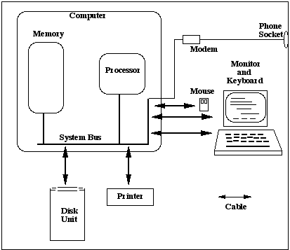
Typical computer system: Processor and RAM
Extracted from http://www.csi.ucd.ie/staff/jcarthy/home/Comsys_notes.html on 16 August 2013.

2.2.5 E-readiness and ICT role for Development
E-readiness is quite critical in organizations therefore there is need to be fully ready if it ca be viewed as a performance organization and for the betterment of Organization there should be availability of ICTs and personnel with ICT skills. Many organizations view ICT readiness as a major aspect in articulating the role of ICT for performance. In view of this David Gichoya, (2009) reviewed that e-Readiness refers to the government ability to take advantage of the ICTs as a facility to enhance and improve its administrative functions. The above literature critique is a major aspect in the development of ICT strategies for betterment of Organizations and it harnesses the impetus role of having available ICT in organizations. In which it agrees with, The Harvard University (2013) defines the ‘e-ready’ society as one that has the necessary physical infrastructure (high bandwidth, reliability, and affordable prices), has integrated current ICTs throughout businesses (e-commerce, local ICT sector), communities (local content, organizations online, ICTs used in everyday life, ICTs taught in schools), and the government (e-government). In addition to e-readiness of organisation according to Laundana (2008) in Wikibooks (2013) states that It is important to take a government-wide inventory of assets. After determining what it has, a government must determine the quality of what it has, as well as what it does not have. Then it must write out a shopping list of what it needs to make e-government happen. African countries like South Africa are viewing ICTs as a crucial aspect for the nation building given the helicopter view of e -Government spearheaded by the Results based management programme introduced in the Government operations now stretching over to the private sector .Therefore the e-readiness in the Public sector plays a crucial role in the effectiveness of organisational performance and satisfaction of the public on service delivery aspects.

Figure 2.3 : The Civil Service Commission e-government Survey report of 2013
The above diagram further illustrates e-government as the platform/ meeting point between local authorities, government business and citizens with the use of ICTs for the performance of Ministries, CSC Report (2012). Mantiziba (2013) further stated that ICTs systems and e- redness in Government of Zimbabwe seeks to enhance government accountability and transparency, involving stakeholders and accommodating the public will in the information age. More information delivered in a more timely fashion to citizens is expected to increase the transparency of government. He agrees with Baril and Thompson (2007) on Management Information Systems therefore , he added that ICT Systems and e-redness in the Government of Zimbabwe Ministries and Departments is viewed as a positive channel for enhancing trust in governments through government accountability and by empowering citizens therefore it plays a critical role.(CSC Report 2012).This reviewed literature shows how Governments are aware of the role of ICT in the performance of Ministries, local authorities, private and general public as a whole.

2.2.6 Database Management Systems in ICT Usage
Nengomasha (2009) stated that Database management systems (DBMS) are widely used in public administration. They are used either to manage transactional data or as a source of information to be processed in view of this The Results Based Management team in Malaysia (2012) maintained the importance of computerised systems in line with the RBM Framework linkages for Public Sector Performance as illustrated in the Malaysian Government below diagram
Figure 2.4
Government of Malaysia Results based management view report of 2012
The government of Malaysia (2012) reported that the entire RBM system is supported by monitoring and evaluation system and this in turn is supported by ICTs and computerized systems which ensures that the information generated by the M&E system is systematically utilized in an effective and appropriate manner. In line with this it agrees with Zunguze (2008) in her analysis of ICT e-readiness in 2004 plotted out that e-readiness survey was “carried out to assess Zimbabwe’s readiness to become an information/ knowledge-based society.” Zimbabwe’s e-readiness according to Mhlanga (2008), the results of the survey were used to formulate the country’s national ICT Policy and e-strategy and plot the roadmap towards a Government of Zimbabwe (2008) Global Political Agreement. All this aspects depicts that many Government are working towards the betterment of their nation by emphasising the use of ICT for Organisational performance.ICT plays a crucial role for the effectiveness of the RBM system in that without the availability of ICT,RBM function will not be fulfilled as it emphasizes the connectivity of all Government operations

2.3 ICTs Literacy for Capacity Building and Organisational Performance
ICT literacy is critical in everything therefore measurement of it and its impact should be well reviewed so that its results will yield development in ICT growth.
2.3.1 ICT literacy Impact
ICT literacy or Information and Communication Technology literacy is the ability to use digital technology, communication tools and networks appropriately to solve information problems in order to function in Organisations. This literacy would include the ability to use technology as a tool to research, organize, evaluate and communicate information. It also add up according to the findings that ICT literacy have a fundamental understanding of the ethical and legal issues surrounding the access and use of information according to Litlebyte99 at Ask.com (2013).Therefore it is crucial for users to possess such skills for the effectiveness of ICT usage for Organisational Development. Adding to the ICT literacy importance President of Kenya in (2012) stated that every Kenyan should be computer literate, this he said at the launch of the National e-Learning Programme . In this regard it shows that the President of Kenya is much concerned about the ICT literacy for the employees of the public sector of his country. Agreeing to what Fienna and Bernard (2012) who harnessed the importance of ICT, The President acknowledges the role of ICTs as it provides a whole new world of opportunities and means for individuals to pursue their passions, learn and empower themselves economically and besides for the betterment of Organisation.

Addition to the words of Cathy (2013) agreeing with Zengeya (2011) on ICT literacy as a required factor for Government performance and development. In addition to the literacy , Zimbabwe has an Information and Communication Technology (ICT) Policy requiring all Government employees be exposed to computer skills (Government of Zimbabwe ICT Journal, 2012). This means that computer literacy skills for all Government workers are critical in Zimbabwe efforts to introduce effective ICT programmes in the Public Sector in its Public Service Training institutes institutions. This add up on a great note back in 2008 era, Chetsanga (2008) when notes that skilled Public Sector employees have been migrating to other Countries like South Africa in large numbers, the greatest loss occurring in the education and health sectors and this has resulted in a serious shortage of teachers with computer literacy skills within Zimbabwean schools.

Further on that note, Munetsi (2012) Reported that the level of information communication technology literacy among Zimbabweans has raised to 72% as the country continues its migration from analogue to digital. Critiquing the above notion it adds up to what ICT Minister, in an interview with zejaworld.org (2012), he commented that the gun that will defeat poverty, marginalisation or illiteracy in Zimbabwe is ICT and the ministry has lobbied Finance for the exemption of all ICT products from paying duty. The critique review evokes the impact of ICT it has in a nation and the importance of having ICT skills to employees.

2.3.2 ICT Training Skills
Educational Testing Service (ETS) (2013) illustrated that ITC literacy is the ability to use digital technology, communication tools, and/or networks to define access, manage,integrate,evaluate,create, and communicate information ethically and legally in order to function in a knowledge society. Smith (2009) agrees with the literature by stipulating that there is much importance to measure ICT Literacy in the public sector .Responding to the ideas of ICT training ,The herald November 2012 on ICT environment of Zimbabwe reported that Lack of skilled manpower to train in using Information Communication Technologies from the earliest stages in schools is one of the major challenges facing Zimbabwe. Kundishora (2012) when he was addressing participants at a workshop to validate the draft National Information Communication Technology policy framework, identified that access to ICTs should be spread across the country to raise levels of competence to use the scientific devices. This is a clear notion that Governments are working tireless in developing ICT issues for the improvement of the public sector performance to downgrade the cries by the public on the low service delivery being caused by inefficient of systems whereby paper based systems is on high usage in Ministries

2.3.3 Global view on ICT Literacy

The United State of America Public Sector report of (2012) commented that the ICT literacy is crucial for economic leadership and employees who lacks ICT skills has fewer opportunities for personal advancement, and a society that lacks an ICT literate workforce will not compete in the global economy. This agrees with the CSC Report (2012) which stated that Ministries/Departments often lack in-house expertise and project management skills to undertake major e-government. In addition to ICT skills, Anderson (2010) states that governments generally recognize that along with national ICT policies students need education or training in new ICT skills if they are to function in the changed global environment

In terms of training for ICTs Governments of developed countries like United Kingdom as in Bilton (2013), Goble (2013), Terry (2013) and Woodrow (2013) in which they argued that the Ministries and departments should consider how to optimise the deployment of ICT and commercial skills across central government. In the analysis the recommendations also stipulated that the United Kingdom Comptroller and Auditor General (2013) further reviewed that the expert assistance has been successful and a similar model could be applied to share government’s specialist ICT and commercial expertise to stimulate the most reform In this it agrees with the findings that Nations should set up training skills across the Ministries and Department for effective use of ICTS to keep abreast with Technology according to Munyaradzi (2012)

Adding to training aspects ,Bilton (2013), Goble (2013), Terry (2013) and Woodrow (2013)stated that Public Sector need to show strong leadership in civil service reform beyond the ICT profession. Accounting officers, finance directors and other senior civil servants are interested in overall value for money and managing the risk of change, rather than ICT details. They are not all convinced of the benefits of sharing ICT infrastructure and other business services. All these aspects reviewed that ICT literature is about everyone in an organisation not to separate but to stretch across in all areas not accounting but also the records keepers also. In spite of the views by Kundishora (2012) when addressing participants at a workshop to validate the draft NICT Policy Framework said that Government need to look at the skills levels in the country with regard to ICTs. Therefore according to his speech it clearly demonstrated that the Governments are pursuing various programmes, some Governments are equipping training centres in an effort to raise ICT literacy levels . However as a respondents to this Nwaokwa and Okoli (2012) stipulated that there is lack of skills in the area of webpage design, desktop publishing, office application, networking, proficiency in accessing the internet. In view of the aforementioned problems the researcher tends to study those communication technology skills required by secretaries in their various offices and the influence they have on their job performances. This aspect should also trace to all employees of organizations. Secretaries play a crucial role especially in the Public sector therefore ICT skill is quite impetus. Lack of ICT literacy in the public sector employees will yield poor performance of Ministries resulting in huge numbers of public complains in terms of service delivery.
2.4 ICT Security Issues and ICT National Policy

2.4.1 ICT Security
One of the main issues with ICT today is security. Previous research findings into ICT security issues have reported a global witness of the flourishing of a myriad of electronic attacks, malware, vulnerabilities and intrusions in the domain of information and communication technologies (Schneir, 2008; Brooth,2010).According to Schneier (2008), a well known cryptographer, ICT security issues are not encountered only in the cyber space, but their impact is more noticeable and considerable in this domain. On this it agrees with Beqiri (2008) who reports that Information and communication technologies (ICT) have noticeably shaped several aspects of our lives and contributed to major discoveries in science.
In this critique he added that there are problem areas where security related issues are currently impacting in a negative way ICT that is lack of security awareness and training, operating system design and security, open source issues, design complexity and multiple layer approach. Therefore from this finding it shows us that security of ICTs in Government Ministries should be considered on a high note to avoid the security issues mentioned and for the performance of Ministries knowledge of this stipulated factors should be put across for organisational development

Adding to the findings of ICT security when commenting on ICT security in Japan, Shimizu, Kuniko and Koichi (2008) agrees by stipulating that, it is important to deal with concerning issues such as privacy and security, a safe and secure ICT usage, and eliminating the digital divide . The above comments from the three authors stipulates the impetus role of how ICT security plays and emphasis measures to protect data against illegal issues. All these aspects should also be applied in the systems of the public sector of any nation if that nation need to keep abreast of information and protection of public data

2.4.2 National ICT Policy Framework
In collaboration with national ICT Policy in Uganda according to Uganda e-Government report (2011) It stated that the scope of Uganda's National ICT Policy Framework covers information as a resource for development, mechanisms for accessing information, and ICT as an industry, including e-business, software development and manufacturing. Therefore the ICT policies should not venture in one side but is should be a national aspect for the organisational Development. In regard of this it agrees with the Zambian government (2007)who launched its national ICT policy to enable a diversified and export-oriented economy. This shows that nations are making sure to have availability of ICT policies to guard against information abuse and data lost

However, Zunguze (2007) agrees that nations should have ICT security policies when he stated that ICT Policy was officially launched in 2007 in Zimbabwe .On the other side of ICT policies, Mukaratirwa (2007) summarises the salient points of the ICT Policy as:
• An emphasis on convergence
• The establishment of a National Information and Communication Technology Authority (NICTA) that will ensure policy coherence across all sectors of the economy
• The establishment of a single regulator for the ICT sector
• The need to develop a legislative framework to guide the ICT sector in its totality (i.e., including online transactions, telecommunications, postal and broadcasting services) Zunguze and Mukaratirwa (2007).

Zimbabwe has five laws that govern the terrain of information and communications namely Postal and Communications Act (2004) , Broadcasting Act (2001) ,Access to Information and Protection of Privacy Act (AIPPA) (2002) , Interception of Communications Act (ICA) (2007) and Criminal Law (Codification and Reform) Act (Criminal Code) (2004).

However Mukaratirwa (2007) find out that among all the laws there is , no one law addresses issues of online access to information. Therefore from the literature analysis it states that the Government of Zimbabwe seeks to harmonise the legislative terrain in response to the convergence of technologies and to table an ICT Bill in parliament for the improvement of ICT policies in that this will harness then way for ICT security in Government Performance and the nation as a whole.

2.4.3 International ICT Policies
Ji-Xuan Feng (2010) in the analysis of ICT security stated the issue of privacy and information security. On this review it shows that the security of ICTs should be managed with a helicopter view eye especially in the Public Offices for the security of personal data for Zimbabwean society like at the Registrar General’s Offices and all other national documentation agencies. This notion added to the view by Moor’s theory of privacy (2012), which emphasises that privacy must be maintained and respected. This should be harnessed in all sectors of the country as security of Information is an important issue in ICT usage in organisational development

From the above analysis it clearly shows that most Countries are very serious on the issue of ICT security policies. This will make Government Departments to follow procedures and protect the information for national building. Bernd (2008) responded by stating that most people are concerned by the fact that electronic data of Organisation can be used for purposes beyond our control. Privacy therefore has a close relationship with security. If data of Organisations is not secure then this can threaten privacy. This line of argument suggests that privacy requires security and this security if no managed well it affects the performance of an organisation and the public demands from the public sector. The citizens will loose trust and confidence with the Government operations.

Interparty (2009) added and agrees with the above authors in which it states governments should hold confidential information both data from its individual citizens and Government Ministries and Departments specific security data. This observation shows the importance of ICT security in the Public Sector .Information systems should be well managed by skilled workforce to curb ways of information linkages within Government operations in the era of Results Based Management System. In addition to ICT Security and agreeing the importance the United States according to Wiley Rein (2013) reported that there is an increase and disruptive cyber-attacks on government and private networks therefore there is need for businesses to address security issues not only to protect their assets and reputations. This review by Rein stipulates that the public sectors should be well aware of ICT security and emphasis the protection of Government data by securing all systems and networks

.
2. 4. 4. I CT Security of Information Systems
A recent study by tutor2U (2013) involved that ICT systems and tools need to be secured if there are to be reliable in business transactions. Therefore organisations should be able to recover lost data and information when ICT systems are made more secure as illustrated by the diagram below

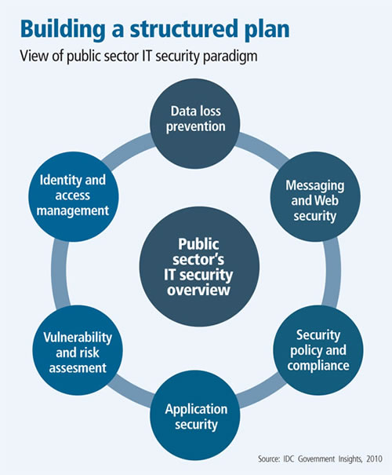

Extracted from http://www.rialtas.net/blog/?p=211#sthash.v5IefzOo.dpuf 10/08/2013

Adding to the above analysed diagram pertaining IT security paradigm of Public sector,the national Information and Communication Technology Policy of Zambia (2013) informed that, the proliferation of Internet and other ICT applications also created opportunities for misuse in Zambia. Therefore, every effort shall be made to ensure that Public sectors should adopts implements and uses ICTs in all spheres of life and put in place security measures to minimise negative impacts on society at large.
2.5. SUMMARY
In this chapter, literature on the impact of the use of ICT for Ministries and Departments performance was reviewed. It was noted that while ICT is a development tool, no human resource development and management programmes will achieve lasting organisational progress when leaders and managers in charge lack the appropriate ICT skills for Organisational performance. Having reviewed the Literature on ICT as a tool for development in the Public Sector, the next chapter will explain the methodology and methods used in conducting the research, how the sample of the survey was chosen and the justification for choosing it. The chapter will also indicate the type of instruments used in the analysis and why they were chosen.

CHAPTER 3

RESEARCH METHODS AND METHODOLOGY

- INTRODUCTION

This Chapter explains the methodology and the methods of how the study was conducted. The research design is described, giving details of how the survey was undertaken, the philosophy of the research, the strategy used in the study, the purpose of the study, how and why the sample was chosen and the method used to collect the data. The Chapter also describes the research procedure followed as well as the limitations encountered during the research on the impact of the use of ICT for Government Ministries’ performance.

3.1. Research design
According to Copper and Schindler (2008) “Research Design” is the plan and structure of the investigation so concerned to obtain answers to research questions. The plan forms the overall scheme or program of the research. It includes the outline of what the investigator undertakes to do from writing the hypotheses and the operational implication of the final analysis of data that would have been gathered using the designed instruments.
A structure is a framework of an organization or configuration, which is interlinked to enable the realization of set objectives in relation to other variables under the study. A research design expresses both the structure of the research problem and plan of investigation used to obtain empirical evidence in relation to the problem. Gibb (2008) explains research design as The design is an activity, which is a time based plan it is also based and guided by the research questions as it outline procedures of each research activity. .The research design will be able to provide answers to what techniques or instruments will be used to gather data?, What kind of sampling will be used?, How will the issues of costs and time constraints be handled? And how will the data gathered be analysed and interpreted?
The researcher used the descriptive analysis for the research. According to Copper and Schindler (2008) the simplest descriptive study concerns a univariate questions or hypotheses in which we ask about or state something about, the size form distribution or existence of a variable. The researcher identified various hypotheses among them that, the use of ICT in the performance of Ministries was ineffective when it came to insufficient budget to support the proliferation, maintenance, upgrading and security aspects of ICT. The case study (Public Sector of Zimbabwe) was also used to depict a holistic portrayal of the respondents’ experiences and results regarding Information and Communication Technology and its impact on Ministries and Department performance in the public sector. Accordingly, as has already been mentioned, quantitative research was conducted in order to:
- assess the proliferation of Information Communication Technologies (ICTs) in Government Ministries and Departments in the context of public sector performance
- isolate the role of ICT in the performance of Ministries
- measure ICTs literacy in the public sector for capacity building and Organisational performance
- identify security measures of ICTS in the Public sector in collaboration with the ICT National policy
Figure 3.1 The diagram below shows different approaches to research:
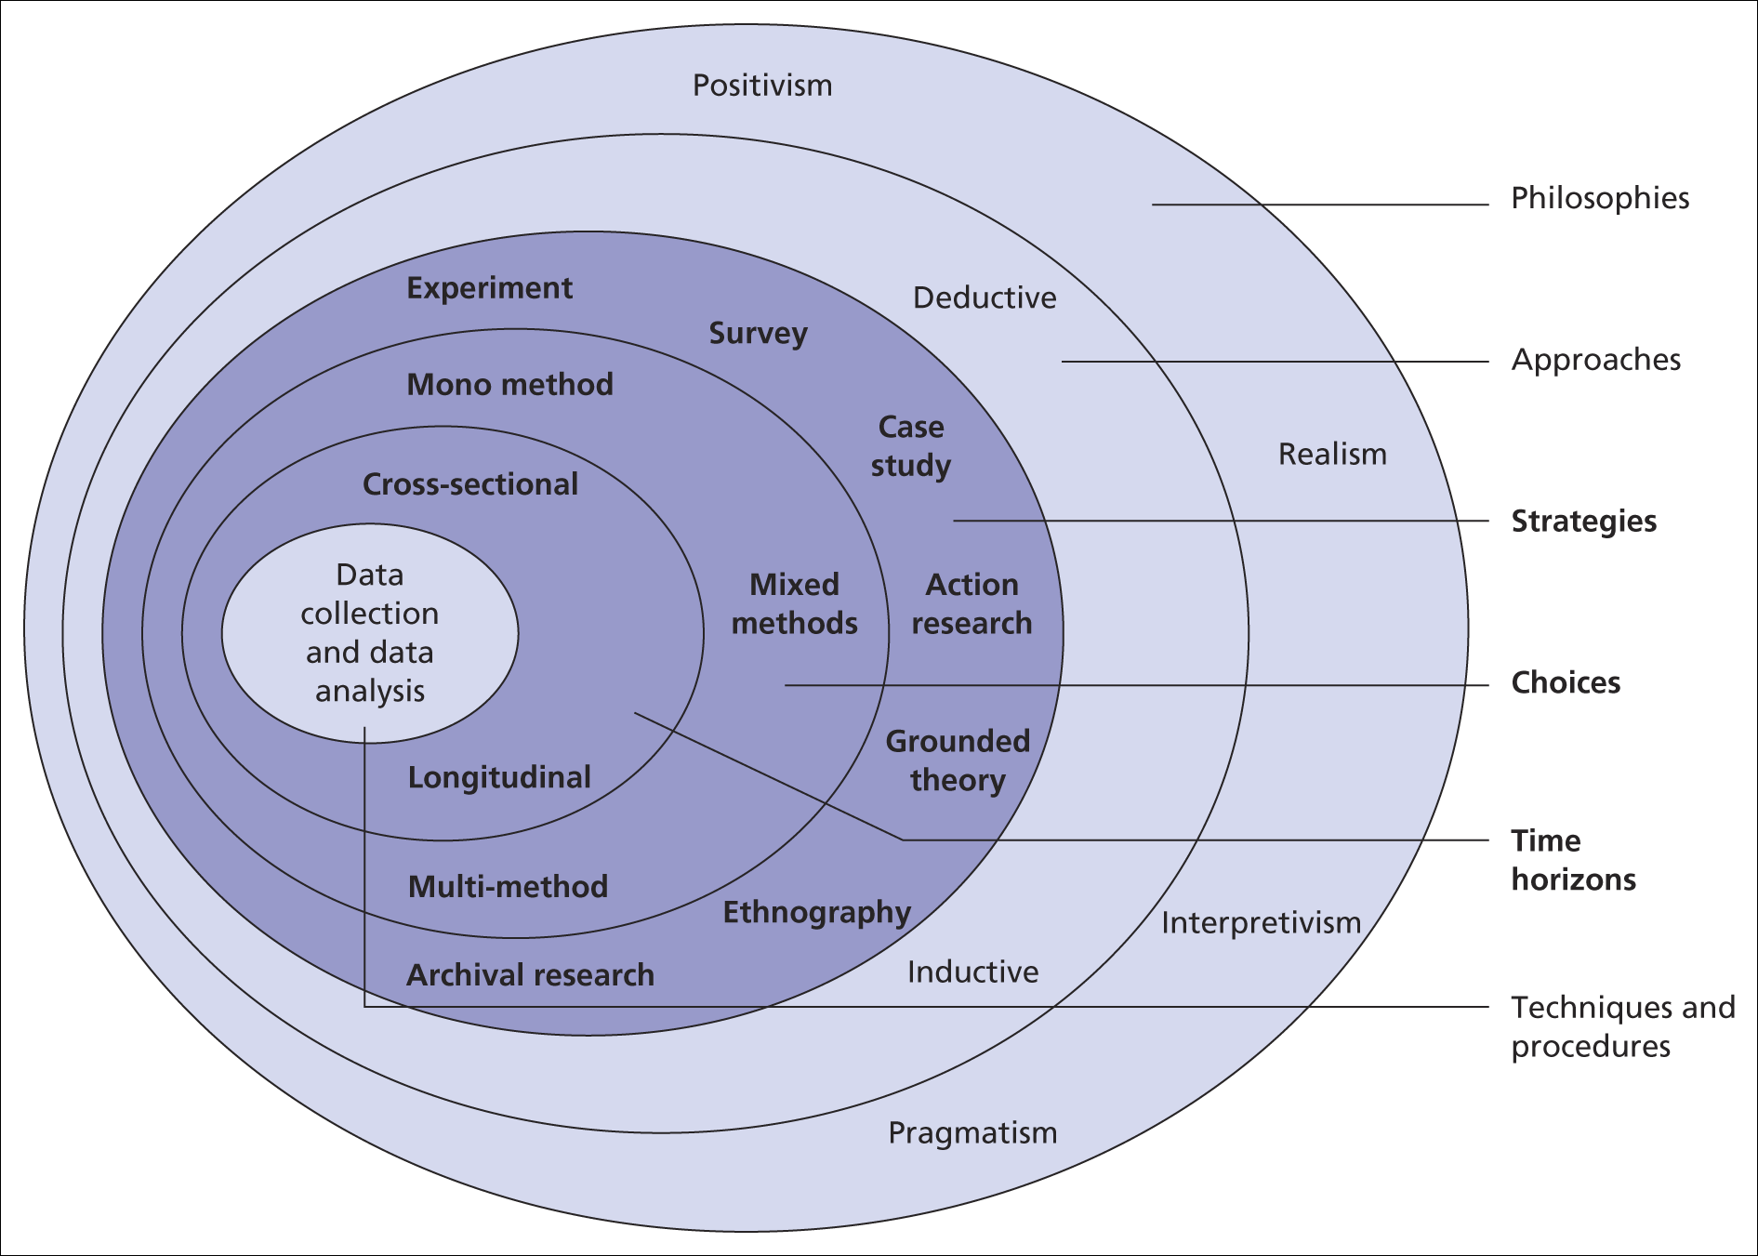
The research process Onion
Adapted from Mark Saunders, Philip Lewis and Adrian Thornhill (2009)
moodle.brookes.ac.uk/.../Week%205%20Formulation%20of%20the%20.
3.2. Population
According to Harper (2008) a population is defined as, a group of people (or items) from which we want information. The target population refers to the total number of research subjects or respondents to whom the study can be generalized. This study focused on the use of ICT its impact on the performance of Ministries, its effect on Public Sector employees including Administration Staff, Finance Staff, Records Staff, Researchers Staff, Educational staff and Communication and Technology staff. The research has a population of 26 Ministries After having identified the population the researcher devised a sample. The sample formed a subgroup of the population chosen which provided answers to questions by the researcher. The data collected was used to infer on the whole population. Below is an example of sample selection.
3.3 Sampling
Sampling is a method of study where the researcher decides to study only part or a subset of the targeted population. A sample is defined by Harpes (2008) as a group of items taken from the population for examination. Consideration from data collected from a subgroup which will be used to generalize on the total group. The sample taken possessed all the characteristics to represent the whole population.
Population and sample
Figure 3.2

26 ministries
Population

(26) Ministries
Ministries
Sample
(5)Ministries

Adapted from Mark Saunders, Philip Lewis and Adrian Thornhill (2008)

Saunders (2008) define sampling as the process of selecting units (e.g. people, organizations) from a population of interest so that by studying the sample the researcher may fairly generalize the results back to the population from which they were chosen.

  - Respondent selection
This study collected its data from a cross section of Ministries, departments and employees at the Public Sector of Zimbabwe. From the researcher’s judgment 10 employees from each of the 5 selected Ministries were targeted to get a sample of 50 employees. The employees chosen comprised of senior managers, middle managers, officers, Office Assistants and Receptionists all users of ICTs. Of these 50 were chosen to complete self-administered questionnaires. The Permanent Secretary for the Ministry of Information and Communication technology was included as part of the research by virtue of his position in a Ministry that drives ICT in the public sector of Zimbabwe. The Permanent Secretary Mr Kundishora is also a former employee of ZARNET which is the network provider in Government Departments. The study could not be finalized without his expertise. The sample under study constituted five Ministries including Ministry of Finance, Ministry of Media and Broadcasting Services, Higher and Tertiary Education, Ministry of Primary and secondary Education, and Ministry of Information and Communication Technology. The research target Ministries which have impact on educational aspect and the Ministries which deal with monetary issues ,communication and Information desermination of the country in this they have much interference with ICT.
  - Research instrument used
The researcher used a self-administered questionnaire as a research instrument to collect primary data from the respondents. Closed ended questions were used because it is easier and quicker for respondents to answer and the answers of different respondents are easier to compare. The answers were easier to code and statistically analysed in that also respondents answer about sensitive topics. Closed ended questions also assisted the researcher in that there were fewer irrelevant or confused answers to questions
The questionnaire was administered to the target groups who are all in selected Government Ministries in Harare hand delivery system was used. This method of data collection provided speedy answers from the respondents as alternative answers were provided. According to Saunders (2009), types of closed questions include list, category, ranking, rating, quantity, and grid or matrix.
List questions give the respondent a list of responses to choose from to ensure that the respondent has considered all possible responses. Saunders (2009). Closed questions provide uniformity of questions and they provide standard responses which will make evaluation of the group as a whole easy. The other advantage is that closed questions save time as they do not take respondents much time to complete. Closed questions avoid problems of interpreting questions and they are easy to process as they enhance comparability of answers.
This study used the self-administered questionnaire because of its applicability to the interpretive survey research design. The major advantage of using the self-administered questionnaire was that it could be administered to a number of employees at the same time. Moreover, this method was cost effective and convenient in collecting data. Fifty (50) questionnaires were administered to (5) Government Ministries of Zimbabwe. However not all respondents could complete the questionnaires in time. The key themes outlined in the literature on the extent to which ICTs has affected the operations of Government Ministries and Departments and shed light on whether ICT is a prescription for Public Sector performance and development includes
- proliferation of Information Communication Technologies (ICTs)
- role of ICT
- ICTs literacy for capacity building and Organisational performance
- security measures of ICTS and ICT National policy
- challenges in ICTs management and implementation

Questionnaires sought to probe these ideas in relation to the employees and their views on the use of Information and Communication Technology in the performance of ministries.

  - Advantages of a questionnaire

Self-completion questionnaires are cheaper to administer than interviewing especially if the researcher’s sample is geographically widely dispersed, Bryman , and Bell (2011). Many issues of questions and concern can be addressed in an efficient way.
Questionnaires permit anonymity and therefore respondents will freely answer without fear of victimization which increases the response rate. Also interviewer effects, Bryman, and Bell (2011), are eliminated. Characteristics of certain interviewers such as ethnicity and gender, for example, may result in bias. Many people, when they are completing self questionnaires tend to freely express even sensitive issues which they are unlikely to do, say for example, in interviews. Self completion questionnaires enable respondents time to complete it when they want and at their own speed, Bryman, and Bell (2011)
  - Documentary search and Desk Study
The researcher also accessed policy documents in the Records Office and the Project Office, relating to the introduction and implementation ICT Systems and the use of ICT in Government Ministries of Zimbabwe. The documents provided ICT policy guidelines in the proposed policy changes and indicated the objectives to be achieved. These ICT documentations provided the researcher with the government strategic plan and the objectives it intended to achieve, through the use of ICT for ministries performance. The following were used: academic journals, magazines, relevant books, relevant policy documents and reports, Public Sector Library sources, University of Zimbabwe Business school library and Midlands State University School Library.

  - Validity and reliability of data
The researcher utilized the duly collected data to arrive at a meaningful conclusion. The instruments used were tested for their reliability and validity.

  - Validity of data
Validity is an attempt to establish the measure used by the researcher on its appropriateness for the scientific research under investigation. It measured the relation between two or more variables. Robson (2007) describes, history mortality, testing instruments ambiguity and maturation aspects which could affect validity of data. In testing the validity of the questionnaire the researcher sought to verify the extent the instrument measures what it is intended to measure. The responses highlighted the validity of the instruments.
3.10 Reliability of data
Reliability is concerned with consistence of measures. According to Copper and Schindler (2007) reliability has to do with the credibility, accuracy and precision of a measurement procedure. To determine the reliability of instruments, similar set of questions would be included on questionnaires given to respondents. The instrument produced the same result when repeated several times to be considered reliable. Reliability seeks to evaluate the instrument, in terms of how accurate and consistent the instrument is to the target group. The members of staff in selected Ministries were assumed to have knowledge and skills on the use of ICT to enable them to answer questions in the questionnaire.
  - Pre-testing
The researcher pre-tested the questionnaire instrument before the wide distribution to ministries. Pre-test indicated its workability and ability to collect the intended data. It provided guidelines in rewording the questions to enable the respondents to answer the questions. The pre-testing of the instrument again gave an indicator on the level of knowledge on ICT of correspondents on the problem under review.
  - Data analysis
Completed questionnaires were quality checked and entered into an data analysis software (SPSS) for analysis. A qualified statistician examined and validated the sample selection, questionnaire design and results generation. Data was collected using the above instrument and the analysis was made using SPSS analysis system which instituted tables, graphs and charts in an effort to bring about the findings of the study. These interventions helped to explain the possible causes and the effectiveness of the use of ICT in the performance of Ministries. The research instruments chosen for this study were questionnaires and desk study. The two methods were used in order to capture the desired information and consequently to produce valid results.

  - Summary

The chapter discussed the research methodology and methods adopted by the study. The chapter further presented the research design to be used, the research philosophy, research instruments, data collection procedure and data analysis. The sampling technique appropriate for this research was also identified as the simple random sampling.
The next chapter will detail the presentation of findings and discussion. In this chapter, data collected from both primary and secondary sources is presented in qualitative terms and possible interpretation and meaning of the findings are made.

CHAPTER FOUR

DATA PRESENTATION, ANALYSIS AND INTERPRETATION

4.0. Introduction
In this chapter, the researcher analyses data that was collected by the questionnaire. The researcher would present the data findings using graphs, tables and text. The findings would be based on sub-questions which would lead to discussion and the interpretations and findings of the study.
  - Data presentation process
The researcher evaluated the questionnaire responses. The findings were consolidated and analyzed. table 4.1 depicts the questionnaire survey response rate.
Table 4.1: Questionnaire Responses
Questionnaire | Quantity | Percentage %
Hand delivered | 50 | 100%
Valid return | 50 | 100%
Non Response | 0 | 0%

Questionnaires were distributed to the selected Ministries of; Finance, Higher and Tertiary Education, Primary and Secondary Education ,Media and Broadcasting Services and Ministry of ICT employees including directors, Accounts, administration ,records and professional staff and fifty responded by the due date. This is an acceptable response rate according to Cresswell (2008). A thorough follow up on distributed questionnaire was done and this resulted in a hundred per cent return. The respondents who participated in the study are shown below.

Figure 4.2.

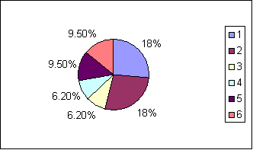
Respondents segmentation

Key
18% Administration staff
. 18% Directors/Management
. 6.2% Records staff
. 6.2% Secretarial staff
. 9.5% Finance/Audit staff
. 9.5% Human Resources
The above pie chart represents the percentage distribution of participants by department in all the ministries studied. It is important to note that the majority of respondents were directors whose information helped clarify issues of policy on ICT in the ministries. The rest are equally relevant stakeholders as they all have a bearing on ICTs. The records staff directly deal with the use of ICTs to capture various forms of data; the secretarial staff do the same just like the Audit staff. The human resources members of staff are part of the regulation framework for all the ministries and that includes designing and enforcing of the implementation of the ICT policies at all levels of the ministries.
Personal Data of Respondents
Table 4.3
Distribution of Participants of Ministries by Gender (n=50)
Ministry | Male | Female
Finance | 5 | 5
Media Information | 6 | 4
ICT | 4 | 6
Higher and Tertiary | 5 | 5
Primary and Secondary | 6 | 4

Figure 4.4
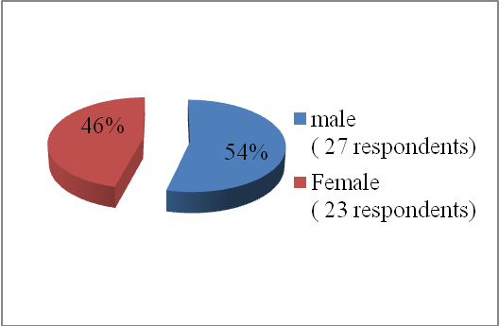
The above analysis indicates that 54% were male and 46% were women. This is a reflection of a reasonable average gender balance. In fact this marks a fair distribution with one ministry actually having more female respondents than others, notably the Finance and Economic Planning. These gender statistics therefore shows that the views gathered are fairly representative of gender.
The pie chart above indicates that of the respondents have at least a certificate, or diploma, 53% have a first degree, 37% have a master’s degree and 6% have a PhD. These statistics are reflective of a highly literate and educated workforce that in turn presupposes subsequent complexity and clarity in all the respondents. The statistics however do not reveal whether such levels of academic education also reflect a corresponding level of ICT literacy. Experience has shown that quite often the reverse is true. This indicates that a bigger percentage of the respondents are educated and their contributions to the study was therefore from an educated and an informed perspective. This also added value to the findings of the study.
4.2 Proliferation of ICT in the Public Sector
Gogo (2012) emphasised that Proliferation of ICT improve the manner in which information is transmitted and it improves speed and information dissemination in operations. However also Bilton ,Goble, Terry and Woodrow(2013) emphasised that Finance Ministries should review ICT budget by making them sufficient. The questionnaire went on to look at the ICT proliferation in the Government Ministries. Considerations pertaining to the budgetary aspects were investigated. The chart below indicates the findings of the level of ICT budget in Government Ministries.
Figure 4.6
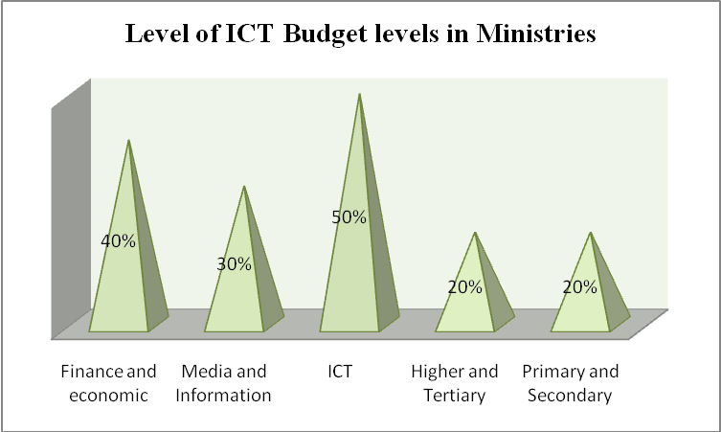
The above chart shows that in the Ministry of Finance 40% and ICT Ministry 50% there is a higher percentage of the level of ICT budget which means the two Ministries are in a better position as compared to the other three Ministries of Media, Higher and Tertiary and Primary and Secondary Education. This indicated the different in ICT management according to Ministries objectives. One can however challenge the credibility of some of the budget percentages. For instance 40% of the budget may appear rosy; it is fairly difficult to believe a ministry can dedicate that entire chunk to ICTs alone when there are several demands from other competing departments.
4.2.1 Level of ICT Usage in Ministries
As what Wheeler (2010) reviewed that ICT proliferation enhances the learning experiences and prepares employees for successful performances. The research went on to find out the levels of ICT usages in Ministries. This measurement was done to know the value given to ICT as well as the proliferation of ICT in the Government Ministries as well as a way forward in making Zimbabwe a technology country in line with vision 2020.The results came out showing that that ministry of Finance and economic development recorded an average frequent usage of 29%. The Ministry of Media and information and Broadcasting services recorded an all-time usage frequency use 50%. This is in keeping with general expectation given the nature of broadcasting. And the Ministry of ICT is on top of all the ministries in terms of usage again as expected as ICTs are the means by which all their tasks are carried out. All the respondents point towards 100% (10+ 30+ 60). On the contrary, the Ministries of Education (both primary and secondary and Higher Education) are generally pointing towards a low usage of ICTs as shown by responses (10%) indicating complete non-use of ICTs in some departments in both ministries. This phenomenon is quite discouraging and may actually explain why there is comparably less organizational efficiency and effectiveness in these ministries when it comes to coordination of institutions in the ministries.
Another aspect of ICTs discussed is networking. Networking is quiet critical in terms of ICT Management and usage of any organisation. For any Country to be ahead in technology networking play a critical role according to Gichoya (2009). Networks are a prime means to facilitate information exchange within the government. Being linked to other organisations and global per se provides opportunities to learn new ways of doing .The diagram below indicates networking systems available including their types in the Ministries

Figure 4.7
Networking System Availability and Type in Ministries
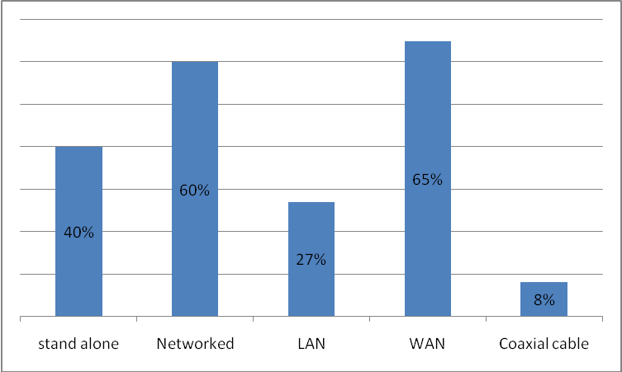
The findings indicated that Ministry of Finance has 60-66% of Network and LAN, Media 50% Networked, ICT 100% Networked and Higher and Tertiary50% same as Primary and Secondary Education. For instance given the nature of the terms of reference of the Ministry of Finance one would not expect 40% of the respondents saying the ministry is a stand-alone. The same observation goes for the Ministry of primary and Secondary Education and the Ministry of Higher and Tertiary Education both of which have 50% in the negative. Undenge(2013) recommended that the use of ICT pays a crucial role to curb corruption in Organisation and has an impact on the GDP. The ideal situation is one reflected by the Ministry of ICT which posted a 100% in the affirmative. However, the other responses indicate that all the ministries network connections to every department were available to a moderate extent with the ICT where connectivity was available to a much larger extent .From the analysis it shows that Ministries are not fully networked as what the former Minister of ICT Chamisa (2013) emphasised Zimbabwe to be a techno country by 2015.
4.2.2 ICT Hardware used in Ministries
The analysis below indicates that Ministry of ICT Media and finance has a higher rate in hardware availability in terms of personal computers, laptops, printers and scanners. As what Thang and Wong (2010) emphasised the rapid proliferation of ICT in Malaysia that they change the performance of companies and organisation because of their efficiency. The findings indicate a high rate to ministries who deal with communication and finance aspects are high in ICT hardware usage and availability .There is low rate of hardware usage in Education ministries. This indicate that the public sector is still behind becoming a knowledge based country by 2015 unless much emphasis is initiated on crucial role of using ICT for the betterment of Ministries performance.

The respondents indicated the use of personal computers, laptops, scored the highest percentage of 100% where as the use of projectors, scanners had their means tending to average two. This indicates that computer hardware and peripherals were rarely used in Government Ministries in selected Ministries of the public sector and this will result in poor performance of some Ministries as comparing to Islamabad (2013) who stated that China’s performance of organisations and companies is being necessitated by the availability of ICT in this there is high productivity.

Figure 4.8
Systems used in Government Ministries
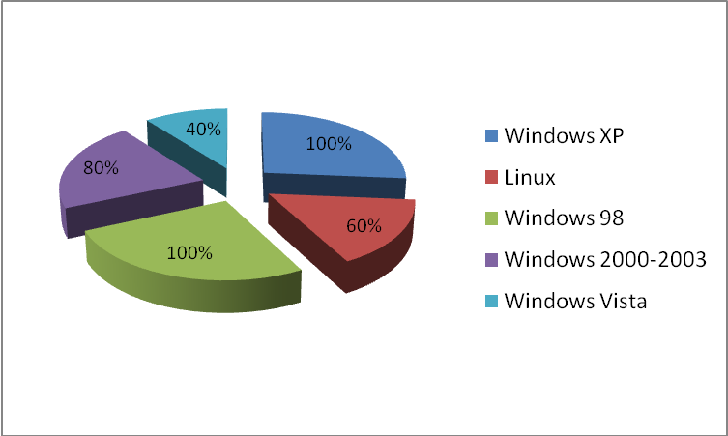
Above are the findings from the types of operating systems available in Government Ministries .The analysis shows that there is a higher rate on the use of Windows XP 100% ,Linux 60% and 100%windows 98,Windows Vista 40%, 80% windows 2000/2003.This shows that there is a greater extent on the usage of Windows XP in most selected Government ministries surveyed. Ministries are not well advanced in systems therefore they need to keep abreast with technology as what Thang and Wong (2010) stated for organisational development.
4.2.3 Application Software in Government Ministries
Application software being used in the Government Ministries indicates that there is 100% use of Ms Office including ms office word applications and accounting packages, that is, the use of PFMS (Public Financial Management System).70% indicated there is the use of records management systems in that some ministries have computerised their records systems from paper to computerised records .There is 50% of Human resources and administration packages in the findings. Thirty per cent indicates the use of payroll packages and this normally is done by Human resources staff and a 20% of special purpose packages especially for the engineers in the public sector. The analysis indicates low percentages in advanced packages and there is a higher focus on Microsoft packages and accounting package usages Kundishora (2012) emphased the use of packages for effective accountability in Ministries especially the accounting, records and administration, in the analysis there is low on payroll ,HR, Special purpose. Below diagram indicate the findings of the Application software being used in Government Ministries.
The positive indications reflected in the chart above can be attributed to the level of efforts and success so far of the re-engineering government program implemented by the ICT Ministry. However, much is still to be done in bringing up the speed of ICT applications usage in Government Ministries as what Fienna (2012) recommends .An increased effort is required in promoting the use of payroll, Human Resources and Administration, records management and special purposes softwares in the above categories of Ministries application. Use of word processing and accounting packages is widespread across the Government organizations, which is quite encouraging but this could also mean that human resources and administration packages are being used in a skeleton state. In Zimbabwe payroll system is maintained in one department of Salary Service Bureau and Civil Service commission which maintains Human Resources Software and this replies the low usage of Ministries on Payroll Human Resources as well as special purpose is concerned.

4.2.4 Role of ICT upgrading issues
In terms of ICT usage of outstations was moderate in all departments and the findings indicated that 100% of work related upgrading issues that the ICT is being prioritised for work related objectives. There is a moderate percentage of social related upgrading issues. For the private related upgrading issues there is a low percentage except for the ministry of higher and tertiary education with 40% for privacy. The Results based Management , Civil service e-government survey report (2012) emphasised the use of ICT to enhance government accountability and transparency to have a positive channel for enhancing trust and empowering citizens. From the above results it shows that there is low on private related upgrading issues will affect ICT literate to some sort.
The pie chart below indicates the extent of maintenance of ICTs by the studied ministries. Maintenance is as good as the ICTs themselves because without it they crumple.

Figure 4.10
The above chart indicate a 40% response that there is insufficient support on the maintenance and updating of ICTs and 30% indicates very insufficient support,10% response indicated that there is a moderate support in the maintenance and updating of ICT systems and tools. Indeed these are disturbing statistics. In fact the general picture they paint is quite gloomy. On the whole neutral, insufficient and very insufficient are all pointing to the negative and their sum of 80% is really disturbing. This depicts there is low support on maintenance and upgrading of ICT systems and application. The national budget (2013) indicated a 26 million injection budget to ICT sector and this might mean some funds are being diverted to some use by Ministries.
As pointed out earlier 80% of non-maintenance of ICTs is a disaster and besides pointing towards potential system collapse, it has serious financial implications for all the ministries as the ICTs will have to be replaced continuously and at a high frequency owing to unavoidable collapsing of ICTs due to non-maintenance.

4.3 Objective 2: Role of ICT in the performance of Ministries
According to Laudon and Laudon (2008), ICT offer tremendous potential benefits to organizations. In view of this, what is going to be discussed below is to check if the respondents agreed with the assertion. Below are the findings of how ICT has assisted Government ministries in terms of transaction time, transaction cost, complains, backlogs, decision making, queues, documentation and records retrieval.
Figure 4.3.1
Transaction time and Transaction cost
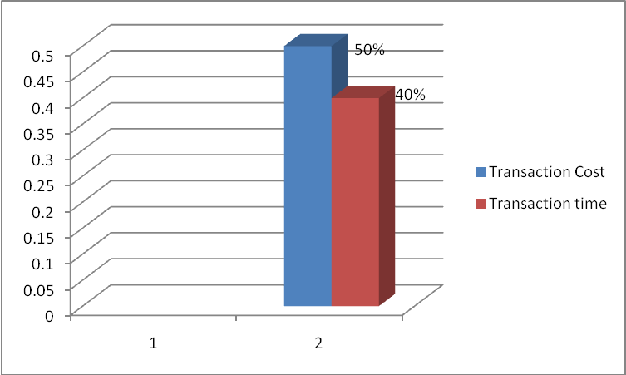
Transaction time indicated a decrease of 40% for ICT use and Transaction cost indicated an average increase of 50% assistance to ministries. Therefore the availability of ICT in ministries have degrees transaction time at an average rate of which this is low according to the requirements of how ICT render assistance for performance. It means there is need to effectively use ICT inorder to reduce transaction costs and transaction time. Therefore the available of ICT should be shown by a decrease of transaction time and transaction cost.
Complains and Backlogs
Figure 4.3.2
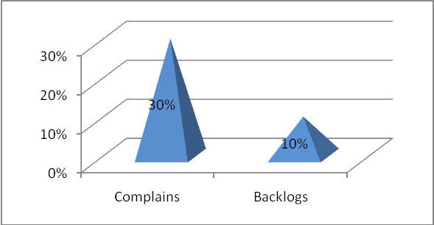
On the issue of complains respondents indicated that ICT has eased the complain issue by 30% .This is a decrease in which ICT is expected to be 100% effectiveneness.ICT shows that they have decreased the backlogs by 10%. This shows that ICT is not being used effectively to solve backlogs as shown by the results
Decision Making and Queues
Figure 4.3.3
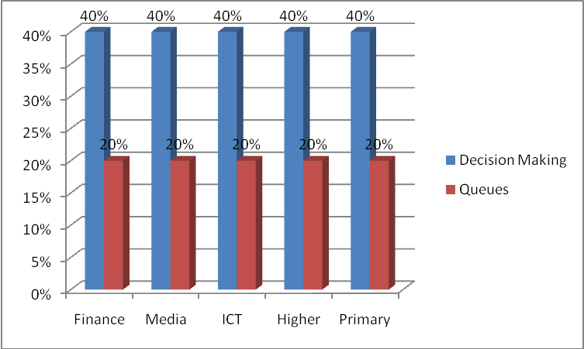
Decision making indicated an increase percentage of 40% as compared to queues which has a decrease of 20% of assistance. Decision making has been increased by 40% with the use of ICT in Ministries and queues have been decreased by 20% in Ministries. The findings indicate that there is still low rate of how ICT have rendered assistance in Ministries
Documentation and Records Retrieval
Figure 4.3.4
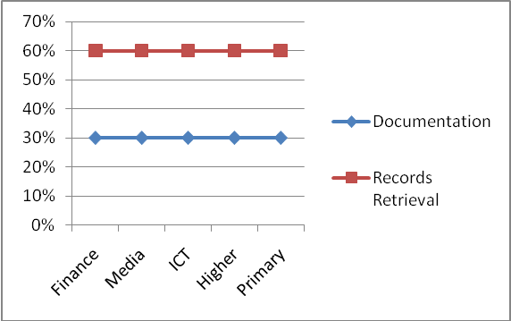
The findings from the respondents indicate that documentation has been eased with 30% but this is a decrease in which it is below average. The availability of ICT should make documentation effective and reduce time and storage areas. Records retrieval indicated an increase percentage in assistance most respondents indicated a 60% assistance. The findings indicate a positive impact on the use of ICT for Ministries performance on records retrieval.ICT have increased records retrieval. Literature of Fienna and Bernard (2012) emphasised the role of ICT for organisational development in all operations therefore the findings indicate skeleton use of ICT in that it is not fully implemented and this may result in poor performance of some Ministries who deal much with public
4.3.1 Transaction Cost and Time Assistance Comparison with Budget and ICT Usage in Ministries
Figure 4.11
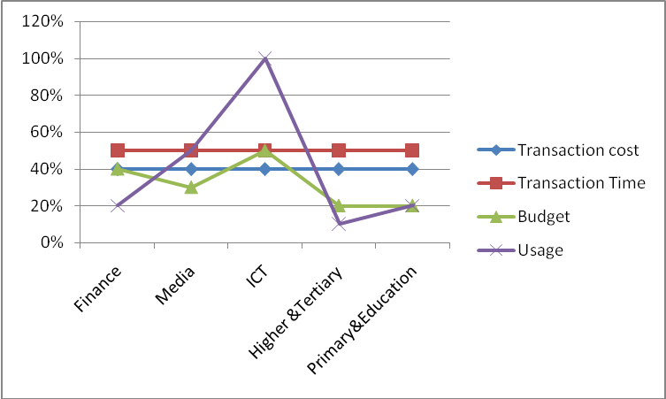
The research found out the trends assistance rendered by ICT to Ministries in terms of Transaction Costs and Transaction time. It was noted that ICT Usage is higher but the transaction cost remained at 50% with transaction time of 40% on how it assisted Ministries. Although some Ministries prioritised more budget to ICT as of Ministry of ICT with a 100% of ICT usage and give 40% of its budget to ICT but transaction time and transaction cost did not move it stands at 50% and 40%.Higher and Tertiary Education have low budget and usage hence transaction time and transaction cost stand at 50% ,this shows that they manage even with the small budget and the usage to gain50% of transaction time and cost. There is a slight increase in Ministry of Finance on Budget and usage but the transaction time and cost also remains at 50%.According to the Malaysian Government Transaction Cost and Time should increase were there is high usage and high budgetary concerns of ICT hence that is not the scenario with Zimbabwean Ministries.
4.3.2 How Complains and Backlogs assist comparing to the availability of Networks and Hardware in Ministries for Ministries Performance
Figure 4.12
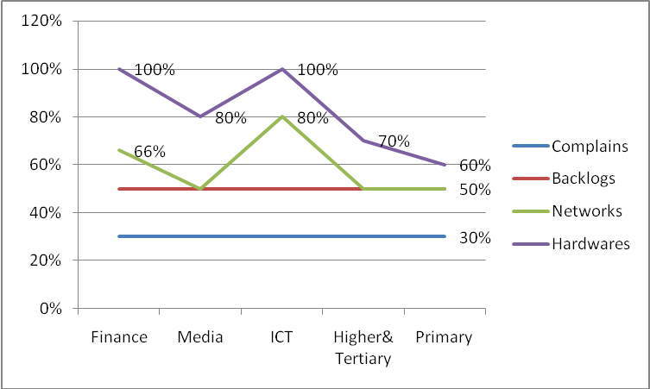
The above comparison indicate that complaints has been eased by the use of ICT with 30% in Ministries and a 50% assistance of ICT on backlogs. However it also shows the high percentage availability of hardware and Networks available in Ministries which is suppose to be the reverse that the availability of hardware and networks should improve backlogs and complains due to the efficient and easy retrieval of Using ICT. It shows that ICT are not being used effectively in Ministries because the hardware and networks are available in Ministries but there is less attention to complains and backlogs. Comparing to what the Independent Evaluation Group of World bank (2013) harnessed that the use of ICT increase service delivery and improve governance

4.3.3 How ICT assist in decision making and queues comparing with availability of hardware, and ICT usage in the performance of Ministries
Figure 4.13
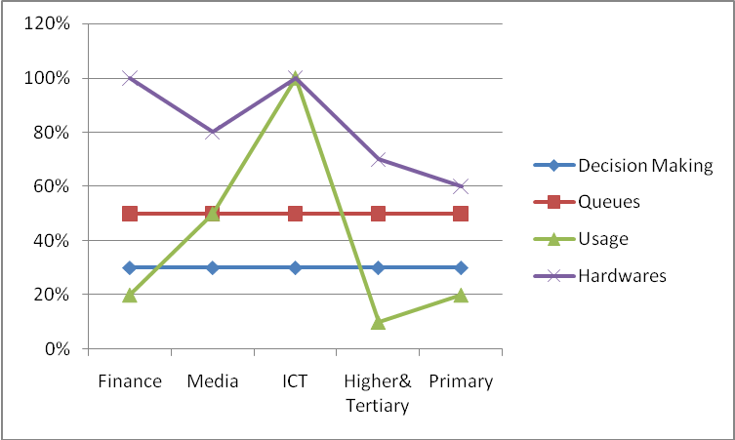
The above comparison shows how ICT has helped in queues 50% and 30% decision making. However comparing to the ICT usage and availability of hardware in Ministries there is high in Ministry of ICT on usage with 100% and 60-100% of hardware availability in all ministries but the comparisons indicate an average trend assistance of the role of ICT in decision making and queues shows negative impact with decision making 30% and 50% queues. In this comparisons it also stipulates that The usage of ICT in Ministries and Hardware have a medium impact in decision making and reducing queues maybe this may be caused by lack of ICT skills and appreciation by employees .Employees may be taking ICT in their respective Ministries as personal tools not venturing for the performance of the Ministry as a whole. Carega (2009) emphasised that ICT should play a critical role in speeding up the flow of information between governments and citizens and transforming the way in way in which governments and citizens interact. Therefore the findings indicate the negative in which even though there is availability of hardware and high usage in Ministries still there is no improvement increase in solving queues and assist in decision making.

4.3.4 A comparison of how ICT assist documentation and Records retrieval and the availability of application software, literacy and management support in Ministries
Figure 4.14
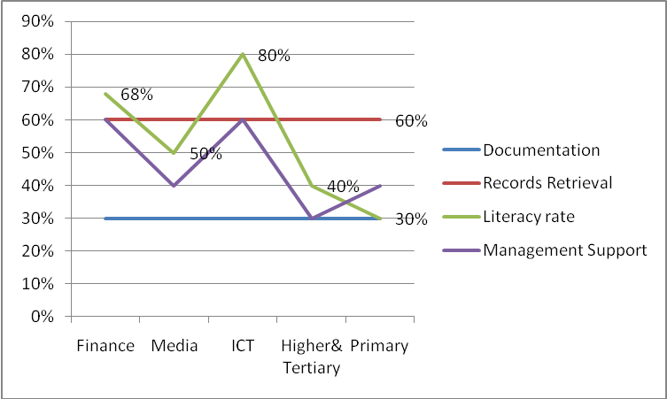
Records retrieval has 60% benefit through use of ICT and documentation as low as 30%.Comparing on the availability of literacy rate from ministries of ICT and Media which indicate 60%-80% it shows that there is no efficiency on the documentation, employees are not using their skills to practice for the Betterment of Ministries. Where there is high management support there is an increase advantage of records retrieval, this may be necessitated by effective supervision of the management in some ministries. Where there is low management support and literacy rate it affects documentation and retrieval of document. As what the Civil Service report (2012) indicate that to enhance accountability ,proper use and transparency there is need there is need for management support to enhance effectiveness in Ministries. Acquired skills need to be practiced in business, this tend to be a reverse of the Public Sector employees who does not use acquired ICT skills effectively for the better performance of Ministries as what the Educational Testing Service (ETS) (2013) insisted.

Figure 4.15
Role of ICT in Job Execution (n=50)
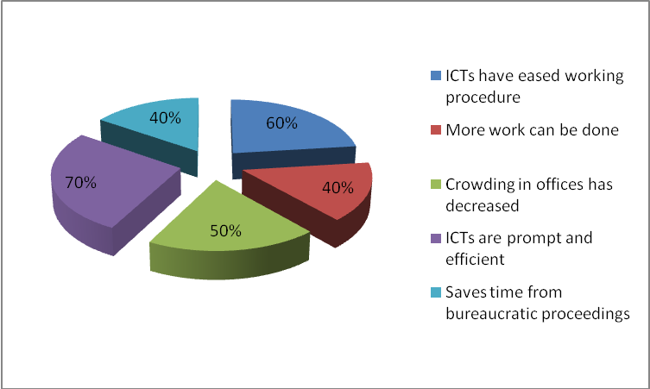
60% strongly agree,40% agree,50% neutral,70% strongly agree, and40% agree. A high percentage of 60% and 70% of the respondents strongly agree that ICTs have eased working procedure.40 % of the respondents indicated that they agree and some are neutral in that ICTs can result in more work to be done. On the issue of overcrowing in offices respondents indicated that they are not much sure of the role of ICT, this has been shown by a 50% response of neutral or even undecided.70% of the respondents strongly agree that ICTs are prompt and efficient.40% of the respondents agree that ICT saves time from bureaucratic proceedings. The above analysis indicated a higher percentage in ICT prompt and efficient and easing working procedure in the performance of Government Ministries. In this Ministries are appreciating the use of ICT with some are not much sure of some areas of the role of ICT especially on queues.
4.3.5 Time when Ministry Plans to cooperate with other Ministries (n=50)
The research need to come up with an analysis of when do the Ministries plans to cooperate with other ministries. On the issues of the joint website 80% on the respondents indicated that they do not even know when it should be implemented. The purchasing of ICT infrastructure indicated a plan of 70% as from 2014 to 2015.There is a high percentage that Ministries are currently in the process of development acquisition of applications 50%,operation,maintenance and ICT usage 90% and purchasing of products through internet 100%.This indication shows that Government Ministries’ joint website/portal need to be initiated for the smooth flow of information in Ministries in this technology will be high in the execution of services and building of the nation.
4.3.6 Extent of Impact Barriers have on ICTs (n=50)
Barriers which impact on ICTs include errors/defects in supplied software, inflexibility of ICT suppliers, lack of integration between applications, lack of ICT qualified staff, difficult to recruit or retain ICT staff, Reluctance among staff to use ICT, lack of updated ICT strategy by ministries, lack of commitment by management, prohibitive ICT expenditure and premature introduction of new versions of existing software. Of all the statistics the most disturbing are indications that lack of integration between applications is about 80%; 90% extreme impact of reluctance among staff to use ICT; 80% premature introduction of new versions of software to the detriment of ministries and 60% extreme impact of ICT strategy absence, Surely such barriers inevitably retard ministerial service delivery. The barriers, both internal; and external predominantly point to the lack of skills and a lack of awareness. Nengomasha (2009) therefore, education and training for the public sector employees can be used to overcome these barriers..
4.3.7 ICT Functions handled by External Suppliers or Own Ministry Staff (n=50)
Results indicate that the following are functions handled by all ministries: Project management at ICT acquisitions, developing ICT strategy, programming/design of internet solutions, other system development, operations of Ministry server, operations of PC environment, user training and user support. All the statistics indicate a generally positive trend. Whether functions are provided by only external suppliers, mainly internal suppliers, mainly external suppliers or combination; the positive thing is that these functions are acknowledged as being done. Education and training is viewed as being crucial to addressing the lack of readiness of ICT in adopting and developing ICT usage. Intervention from industry is also important for the provision of external support according to Harvard University (2013) recommendations.

4.4 Objective 3: ICT literacy in the public sector for capacity building and organizational performance
Munetsi (2012) earlier reported a 72% increase level of ICT in Zimbabwe, however the research need to find out the level of ICT in the public sector. The histogram below shows the different ways ICTs are used to advance different areas of literacy in the ministries.
Indications are that ICTs are used for self-study, pursuing academic qualifications, doing external short-term courses, in-house training, trade certification, improving job skills and doing internal short-term training. Although there are varying levels of such uses in all ministries the satiating point is that all these uses are evident in all ministries.
The various uses above have naturally translated into acquisition of various computer skills and knowledge by government employees as shown by the chart below:

Figure 4.17: Knowledge of ICT Employee Have (n=50)
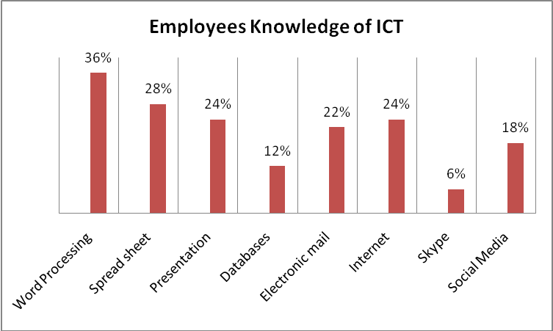
Employees have gathered knowledge in the following areas: word processing, spread sheets, presentations, databases, internet communication including various social media. This is a development that will inevitably improve their work efficiency.
However, in their interaction with ICTs these employees also come across barriers which are captured in the table below.
4.4.1 Hindrance to Computer Use by Government employees (n=50)
In spite of the varying levels of impact shown by the respondents, the hindrances highlighted compliment findings on barriers. Nevertheless, the employees have also benefited from their use of ICTs as shown by the bar graph below:
The bar graph shows that about 12% of the workforce in all ministries did not undertake any ICT training, but of those who received such training significant 68% have significantly improved their work delivery. This is an encouraging observation.
4.5 Objective 4: Security measures of ICT in the Public Sector in Collaboration with ICT National policy
All departments have been in compliance with ICT Security policy documents and the following table summarises frequency of updates of ICT policy per ministry. This indicates the positive advantage according to Mukaratirwa (2007) in which the objectives of the National policy was stipulated .
Figure 4.19
Frequency Ministry Updates ICT Policy Document
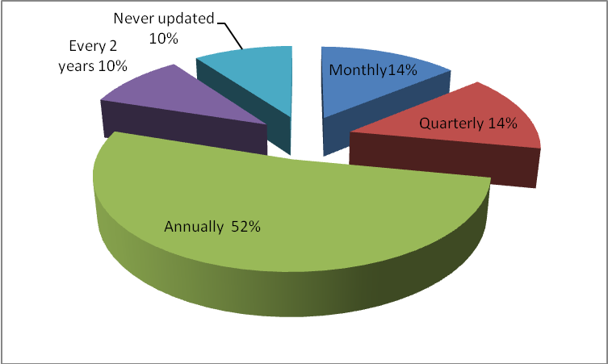
It is as pointed earlier that we still have zero compliance in the Ministries of ICT and Ministry of Media and Broadcasting Services of all ministries. These are ministries that are expected to take the lead when it comes to reviewing ICT policies to keep abreast with ever changing global trends. The Uganda e-Government report (2011) recommends the available of ICT policies and Zambia also recommends the update of ICT policy to keep abreast with technological advantages. The fact that the same ministries confirm reviewing in other categories shows that the respondents may have been genuinely confused by the question which admittedly shows some inherent contradictions.
4.5.1 Rating of Management Support in terms of ICT
Management support is not as good as it should be in all ministries. The respondents shows that management is low or medium together totalling 70% (24 + 46). Surely without management support ICT usage will suffer a big blow and this affects productivity dismally. Rein (2013) emphasised businesses to address security issues to ensure policies are properly focused and not to create more harm than good. This finding from respondents confirms an earlier observation that management are generally not supportive for reasons that are not quite. One can only guess that perhaps financial implications deter management from full commitment to ICT usage. Surely would not think of any other rational cause for resisting gadgets which evidently improve work efficiency quite to the advantage of all.
4.5.2 Rating of controls
Finally, below are graphs which measure rating controls. The first graph is in keeping with the overall observation that management involvement in ICTs is very low. Safeguarding of confidentiality is clearly low. The highest compliance of 48% is far from average expectation.

Figure 4.21
Rating of Management structure and control to protect Ministry Data
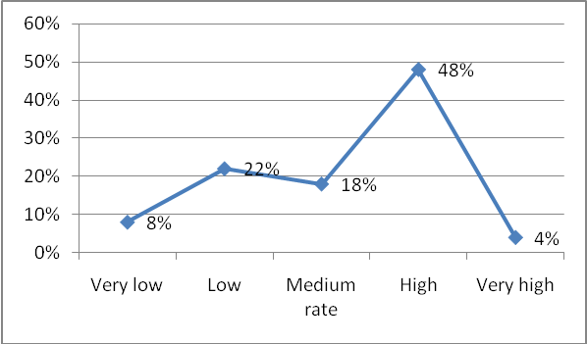

The third graph shows that an average of 50 % is points towards awareness of ICT policies on protection of privileged information. When one compares this awareness and lack of implementation by management, one is left with no choice but to observe that they lack will. This observation is in keeping with the lethargic attitude that characterises civil servants – the tendency to regard government duties as peripheral. Shimizu, Kuniko and Koichi (2008) recommends the issue of privacy and security to be addressed effectively and promptly and measures against all the ICT threats .Therefore the analysis shows that the management support is low as what the Zambian Government recommends as well
4.5.3 Chapter Summary
On the whole there is overwhelming evidence that all the five ministries studied make use of ICTs with the Ministry of ICT and Media and Broadcasting Services topping the list. Several barriers and benefits have been highlighted. The most disturbing finding, however, is lack of commitment by management to train staff, service ICT gadgets and to control and protection public secrets. The research also stipulated that there is lack of employees commitment in the use of ICT, the acquired skills are not being put in full use when comparing ICT literacy in terms of how ICT have eased documentation and records retrieval. Despite the available of hardware and software, moderate ICT use, availability of networks there is no much improvement in terms of performance rating from low results of transaction cost, transaction time, complaints, backlogs, decision making, queues, documentation and records retrieval in Ministries. Despite vast advantages ICT have in Organisational advantage it is not shown in the Public sector of Zimbabwe.

CHAPTER 5

SUMMARY, CONCLUSIONS AND RECOMMENDATIONS

5.1. SUMMARY

The study sought to assess the use of ICT for the performance of Government Ministries of Zimbabwe Public Sector. The study was largely prompted by the fact that ICT adoption and penetration is very low Zimbabwe and more so in the public sector. On the other hand, Government employees have different perceptions and attitudes towards the use of ICTs in their workplaces with some viewing Information technology as more of entertaining tools than working tools which hinders the performance of ICT in achieving positive organisation outcomes.
The case survey design was used. The questionnaires were used as the research tools. A total of fifty questionnaires were distributed, all the questionnaires were returned representing a study response rate of hundred percent, which is high enough to warrant validity and reliability. In order to address the issues of validity, reliability and objectivity the research instrument was pre-tested before administering them at full to the sample.Initial data analysis was done during the research using the SPSS (Statistical Package for the Social Sciences) data analysis and descriptive analysis. Themes that emerged from the data were picked. The data collected was collated, summarized and interpreted. The researcher used quantitative techniques for presentation and analysis of the data. The technique was appropriate since the objective of the research was to assess the impact of the use of ICT for the performance of Ministries. Tables, graphs and charts were used in presenting the research findings.

The major findings of the research were that ICTs are beneficial tools in terms of Ministries operations. Several barriers and benefits have been highlighted. The most disturbing finding, however, is lack of commitment by management to train staff, service ICT gadgets and to control and protection public secrets.

The research also established that workplace rules and regulations did not provide effective monitoring of the use of ICT tools. The research also discovered that there could be improper supervision and management of ICT tools to be put in place and recommendations were provided to the Public Sector of Zimbabwe ICT development for Ministries performance.
5.2 CONCLUSIONS
Literature on ICT was analysed majoring on four areas:

5.2.1 Objective 1: ICT proliferation in Government Ministries and Departments in the context of public sector performance

The findings indicate that there is insufficient budget allocation to ICT as from the National Budget as what the Minister of Finance has indicated earlier. There is high usage of ICT in Ministries especially in Ministries which deal with the public and the development of technological aspects that is the Ministry of Media and The Ministry of ICT. Hardware and Networking availability indicated a positive impact on the Ministries performance as what the findings depicted. On the aspect of application software available in Ministries it indicated a positive on Ms Office and Accounting in which all Ministries are familiar with. Human Resources , Payroll and special purpose depicts low rate because there are individual Ministries which deal with the Human resources that is Salary Service Bureau and The Civil Service Commission. The role why Ministries upgrade ICT in Ministries indicate a positive impact on work related than Private and social. There is a serious financial implication for all ministries due to non maintenance in which it indicated insufficient of how ICT are being maintained and updated.

5.2.1.1 Recommendations

There is need for the Government of Zimbabwe to avail enough budgets to Ministries in Terms of ICT developmental aspects in that this will add value for the acquiring of skills. Ministries need to keep abreast in terms of application packages and make some employees to be aware of Human resources and Administration Packages. There is need to for the ministries to support individuals with enough training rather than venturing on work related issues in which this will result in abuse of ICT gadgets by employees.

5.2.2 Objective 2: The role of ICT in the performance of Ministries

The research also stipulated that there is lack of employees commitment in the use of ICT, the acquired skills are not being put in full use when comparing ICT literacy in terms of how ICT have eased documentation and records retrieval. Despite the available of hardware and software, moderate ICT use, availability of networks there is no much improvement in terms of performance rating from low results of transaction cost, transaction time, complaints, backlogs, decision making, queues, documentation and records retrieval in Ministries. Despite vast advantages ICT have in Organisational advantage it is not shown in the Public sector of Zimbabwe. The findings indicate a generally positive trend on the role of ICT .Whether functions are provided by only external suppliers, mainly internal suppliers, mainly external suppliers or combination; the positive thing is that these functions are acknowledged as being done. Education and training is viewed as being crucial to addressing the lack of readiness of ICT in adopting and developing ICT usage. Barriers inevitably retard ministerial service delivery. The barriers, both internal; and external predominantly point to the lack of skills and a lack of awareness. This findings indicated that Government Ministries’ joint website/portal need to be initiated for the smooth flow of information in Ministries in this technology will be high in the execution of services and building of the nation. The finding from the analysis indicated a higher percentage in ICT prompt and efficient and easing working procedure in the performance of Government Ministries. In this Ministries are appreciating the use of ICT with some are not much sure of some areas of the role of ICT especially on queues.
5.2.2.1 Recommendations
There is need for management support in terms of the role ICT plays in the Ministries in which this will result in poor performance of some Ministries. The availability of hardware and software among ICT gadget should easy transaction time, documentation, decision making queues and complaints in order to render the effectiveness and advantages of ICT in Ministries. Strict Supervision of Staff should be carried to those who acquired ICT Skills in order for the betterment of Ministries. There is need to have a joint portal in Ministries for easy information flow.ICT Ministries should supervise Ministries in the aspect of ICT usage and benefits and emphasised the computerisations of records management systems for effective retrieval of information. The Results based Management Programme should be fully implemented in Government Ministries in that it will assist in the effectiveness of Government operations in the e-Government perspective.

5.2.3 Objective 3: ICTs literacy in the public sector for capacity building and Organisational performance

The ICT literacy rate in the public sector indicate positive in which some ministries have vast Knowledge of ICT hence there is need to use those skills in order to easy information retrieval systems and all the role aspect of using ICT to improve service delivery. This has been shown by the low rate in the trends rendered by ICT in Ministries to speed up transaction time, transaction cost, easy complains, clear backlogs, help in decision making, shorten queues, better documentation and easy retrieval of documents. Employees indicated that ICT have eased their work execution when they indicated much skills on word processing packages despite the lack of more advanced packages and they indicated that in some cases ICT are being used for self study. There are some who have indicated low rate that they do not even possess qualification. There is low availability of funders and many indicate that going for training is not fair

5.2.3.1 Recommendations
The Public Sector of Zimbabwe needs to retrain and expose the employees to new technologies and their applications .It is recommended that employees in Government Ministries and Departments of Zimbabwe need to shift their mindset and totally move away from paperwork to full time technology. It is also recommended that Public Sector of Zimbabwe should consider developing an appropriate ICT education that instils in the employee a sense of self- development of technology, responsibility, accountability and dedication to building the Public Sector of Zimbabwe in particular and the nation as a whole. Management and operations should always be trained or attend refresher courses on ICT so that they are aware of the new developments. The computers should be replaced when the need arises to avoid malfunctioning of the system.

5.2.4 Objective 4: ICT Security measures in the Public Sector in collaboration with the ICT National policy

All ministries indicated they comply with the national policy hence there .The findings also indicated that management support in not as good as it should be in all Ministries in terms of ICT security aspect in which respondents indicated that there did not even have training on security measures and there is weak control of the ICT gadgets in Ministries for the protection of the National secrets for effective service delivery.
5.2.4.1 Recommendations
There is need for Ministry of Information and Technology to put in place legal and regulatory framework that promotes the growth of ICTs. Similarly the Public Sector of Zimbabwe has to come up with right policies and codes of conduct to monitor ICT usage and employee behaviour after carrying out a needs analysis tests.

References

- Abramson, T. (2007) Research Methods for Scholarly, Thousand Oak. Sage
- Anderson (2010) National ICT Policies in Education and Training in Uganda. Volume 4
- Baril, C. and Thompson, R. (2007) Information Technology and Management. McGraw-Hill: USA
- Barnett, J. (2007) Scientific Knowledge and Sociological Theory, Kegan Paul, New York.
- Bennet, W.J. (1995) The Moral Compass: Stories for a life’s Journey. Simon and Schuster: New York:
- Beqiri, E.(2008) School of Computing, Information Technology and Engineering University of East London Docklands Campus University Way London E16 2RD
- Bernd J (2008) Privacy and Data Protection, University of New Yolk: New Yolk.
- Bilton (2013),Goble,Terry, Woodrow(2013) ICT Proliferation in the Public Sector: Australia
- Bilton, Goble, Terry and Woodrow (2013) United Kingdom ICT Training perspective: UK
- Biztech Africa (2013)Information and Communication Technology ,Vol 2 and 3
- BiztechAfrica(2013)Uganda steps up ICT security Government: Uganda
- Broadcasting Act of Zimbabwe (2001)
- Bryman, A. AND Bell,E (2011) Research Instruments :New Delhi,India
- Carega, A.C. (2009)ICT for Development: Consultancy, South Africa
- Cathy, J. (2013)Information Systems: Hardware and Software; New Yolk
- Chamisa, N. (2013) ICT Speech report on World Telecoms day,17 May 2013
- Chetsanga, Prof (2008)Information and Communication in Zimbabwe: Harare ,Zimbabwe
- Civil Service Commission e-Government Survey report document(2012)
- Civil Service Commission Report (2012)
- Civil Service Commission Reports (2009) modernisation in Zimbabwe
- Comptroller and Auditor General of UK (2012-13)Managing the risk of Legancy ICT to Public Sector delivery, HC 539
- Cook,J (2009) Role of ICT for Organisational Development;McGraw Hill.London
- Cooper and Schidler(2007)Reliability and Validity in Research: Japan
- Cooper and Schindler(2008) Research Design: Thousand Oaks: Sage
- Cresswell, J.W (1994) Research design: Qualitative and quantitative approaches. Sage: Chicago
- Criminal Law (Codification and Reform) Act (Criminal Code) (2004).
- Cummings, Haag and Dawkins (2008) ICT and Innovation
- Cummings, J (2002) “The quality of online social relations”; Communications of the ACM 45(7): 103-108.
- David Soute (2010) CTs and development in Zambia: challenges and opportunities: Panos London, October 2010.
- Educational Testing Services(ETS) (2013) Literacy on Information Systems:Public Sector Performance: McGraw Hill; USA
- Fienna and Bernard (2012)Computerised Systems for Organisational Development; McGraw Hill: USA
- Gahadzikwa E (2013) Conference of Zimbabwe Industries (CZI): Business Ethics Speech; Harare ,Zimbabwe
- Gaskins L, E. (2011) The Effect of Information and Communications Technology (ICT) Diffusion on Corruption and Transparency (A global Study) Texas A&M International University
- Gathege,D.(2012) Assessment of Environmental Instituitional and Individual Leadership Capacity Needs for the Knowledge Society in Uganda ,Version 6.0
- Gibb,G(2008) Research Methods: Hyderabad,India
- Gichoya, D. (2009)E-Readness and ICT Role;Kogan,London.
- Gogo ,J. (2012) ICT Proliferation Zimbabwe Business Herald Report
- Government of Malaysia (RBM) Report 2012,Malaysia
- Green Tech Consultants ( 2011)ICT Agency of Sri Lanka (ICTA): Colombo,Sri Lanka
- Haag, S. Cummings, M. and Dawkins, J. (2008) Management Information Systems for the Information Age. McGraw-Hill: USA
- Hankins, L. (1998) Information Technology. Heinz Mann Education: Chicago
- Haralambos, M and Holborn, M (2008) Sociology: Themes and Perspectives. Harper Collins Publishers: London
- Harper,J (2008) Research Practice, New Yolk
- http://www.lazogroup.ca/ms project/framework1-e.php
- Ibrahim Saleh (2013) The impact of ICT on Peace, Security & Governance in Africa:Ph,D Thesis. United Kingdom
- Independent Evaluation Group of World Bank (2013)Information and E-commerce published by Peoples Publishing House On Decent Work,
- Interception of Communications Act (ICA) (2007)
- International Journal of Education and Development using Information and Communication Technology (IJEDICT), 2010, Vol. 6, Issue 3, pp. 3-6.
- International Technology Union, World Telecommunication ICT Indicators databases 2001-2013
- Interparty (2009) Information and Communication Technology Protection,Website.com
- Islamabad(2013) HEC, IT Ministry to work jointly for proliferation of ICT sector :Pakistan
- IST Africa (2013) Conference and Exhibition in Uganda
- Ji-Xuan Feng (2010) Global ICT Policies and Security, New Jersey
- Jovanovic and Rob (2011) Information Technology and Organisational Systems. Prentice Hall: New Jersey
- Kahiigi,K. (2013)ICT Security in Uganda
- Kundishora (2012) Address Speech Workshop Draft National ICT Policy Framework:Harare,Zimbabwe
- Kundishora Eng ( 2013) Report on ICT Development: ZANET: Harare
- Laudon, K.C and Laudon, J.P (2008) Management Information Systems. Prentice Hall: New Jersey
- Littlebyte 99.Ask.com(2013)
- Machi,L.E. and B.T MacEvoy (2009). Literature Review: Six Steps to Success: Thousand Oaks: Corwin Sage.
- Mandizha,A (2013) Newsday Business Report: 23 October Newsday: Harare ,Zimbabwe
- Mantiziba,C (2013) Civil Service Commission of Zimbabwe seminal Paper; Harare, Zimbabwe
- Meijer,Wamukoya and Mutula (2005)
- Mhlanga (2008) ICT Development Reforms Department Office of the President and Cabinet,Harare ,Zimbabwe
- Ministry of Information Communication and Technology (MICT) Strategic Plan 2010-2014.Zimbabwe
- Moor’s theory of Privacy (2012)
- Mukaratirwa (2007)ICT Policy in Zimbabwe:UZ,Harare
- Munetsi,K (2012)ICT Literacy Measurement for Organisational Development: Harare
- Munyaradzi, R.(2012) Results based Management in Zimbabwe, Reforms Department, Harare,Zimbabwe
- National Budget of Zimbabwe (2013) Blue Print
- Nengomasha (2009) Thesis on Database Management ,Nairobi, Kenya
- Nwaokwa and B.E.Okoli (2012) Information of Communication Technology on the Influence Performance of Secretaries in Government Ministries in Nasarawa State, North Central Nigeria
- O’Brien, J.A. (2013) Management Information Systems, Managing Information Technology in the Business Enterprise. McGraw- Hill: India
- Office of the President and Cabinet. Department of Science and Technology. (2005). Zimbabwe e-readiness survey report. Harare, Zimbabwe.
- Pasi,G.(2013) Zimbabwe Revenue Authority Report on use of ICT
- Postal and Communications Act (2004)
- POTRAZ Quarter Statistics
- President of Kenya(2012) e-learning programme; Nairobi ,Kenya
- Proceedings of the 19th ITS Biennial Conference 2012 Bangkok, Thailand
- Records Management Consultancy and Brokerage classroom handout, (2006) ZTTCO, Harare.
- Robson,M (2007) Validity and Research; New Yolk
- Rossouw von Solms (2013) ICT and the turn-around of the Zimbabwean Economy:Nelson Mandela Metropolitan University, South Africa
- Ruhatya (2013)ICT Development in Zimbabwe:University of Zimbabwe: Harare
- Saunders M, Lewis P and Thornhill A (2008) Research Methods for Business Students New Delhi: India.
- Saunders M, Lewis P and Thornhill A (2009) Research Methods for Business Students New Delhi: India.
- Schneir and Brooth (2008) ICT Security;Thousand Oaks,Sage
- Shafika, I. (2007) Survey of ICT and Education in Africa: Zambia Country Report; Infordev. Zambia
- Shigeyuki Naito and Bogumil Hausman (2008)Information and Communications Technology in Japan :Swedish Institute for Growth Policy Studies Science & Technology Office Tokyo, Japan
- Shimizu H,Kuniko O and Koichi F.(2008) ICT Policy in Japan:Meeting the challenges ahead, Ministry of Internal Affairs and Communication: Japan
- Shimizu, Kuniko and Koichi (2008) Information and Communication in China
- SIRDC Diagnostic Study of Public Service Commission systems Report.(2005)
- Smith, P.R. (2007) Marketing Communication An Integrated Approach. Kogan Page: London
- Smith,M.L. ( 2007) ICT Proliferation in Government operations:DRC
- Smith,M.S. (2009)EST and Horne : ICT Literacy: Opening Education Science 323(89)
- Technologies Policy in Japan: Meeting the Challenges Ahead: MIC u-Japan Promotion :Japan
- Thang and Wong (2010) ICT Development in Malaysia Seminal Paper:Malaysia
- The Harvard University(2013) E-ready Society:Harvard: London
- The Havard University (2013) e-redness
- The herald ,November (2012) ICT Training
- The Public Service Commission e-government Survey Report of August (2013)
- The United States of America Public Sector Report 2012
- Theo Tsokota (2012)ICT and the turning-around of the Zimbabwean Economy :Nelson Mandela Metropolitan University:South Africa &Midlands State University, Zimbabwe
- Tutor2U(2013) ICT Security of Information Systems
- Ugandan Government (2012),IST Africa (2012)ICT Development Theory
- Undenge Samuel (2013) Keynote Address to the CZI Conference: Harare; Zimbabwe
- United Kingdom Comptroller and Auditor General (2013)ICT Overview; McGraw Hill
- Wheeler Steve (2010) The Role of the Teacher in the Use of ICT University of Western Bohemia, Czech Republic
- Wheeler Steve (2010) The Role of the Teacher in the Use of ICT University of Western Bohemia, Czech Republic
- Wikibooks (2013) E-Readness:Survey Review,Texas
- Wiley Rein (2013) ICT Security, United States of America Printers: UK
- www.techzim.co.zw
- Wynn, J. (2008) Young People, Well-being and Communication Technologies. Melbourne, Youth Research Centre, The University of Melbourne
- Zengeya (2011)ICT Literacy for Government Performance Zimbabwe;Harare Zimbabwe
- Zenzo P Ncube, JM Hattingh and Armstrong Kadyamatimba (2013)Contributions towards systems for Performance Improvement Proposals (PIPS) for telecommunication proliferation in developing countries
- Zimbabwe National Information and Communication Technology Policy Framework December 2005.
- Zunguze (2008)ICT e-redness Analysis: UZ, Harare
- (2005) National Information and Communication Technology Policy Framework, Republic of Zimbabwe
- (2011)Uganda e-Government Report 2011
- (2011)Zejaworld.org
- (2012) Central and Computing Services of Zimbabwe and Government Internet Security Protection report
- (2012) Civil Service Commission Publications, Volume 19 -25
- (2012) Government of Zimbabwe ICT Journal : Vol 1
- (2012) Zimbabwe Results Based Management Progress Report
- (2012)MICT Policy Framework of Zimbabwe
- (2012)MICT Strategic Plan
- (2013) ICT Policy of Zambia
- (2013) ICT Policy of Zambia
- (2013) Ministry of ICT Report of Zimbabwe
- (2013) Zimbabwe National Budget Report
- (2013)Malaysia e-Government report
- (2012)Access to Information and Protection of Privacy Act (AIPPA)

APPENDIX A


MIDLANDS STATE UNIVERSITY (MSU)
MASTERS IN BUSINESS ADMINISTRATION
QUESTIONNAIRE
FOR GOVERNMENT MINISTRIES PERSONNEL IN SELECTED MINISTRIES
My name is Phyllia Mashumba. I am a student on the Masters Program in Business Administration Studies at Midlands State University of Zimbabwe. I would like to ask you if you would be so kind as to complete this questionnaire. The data collected will be used in connection with my Masters dissertation only. My research is focused on “the use of Information and Communication Technology in the performance of Ministries: A case of Public Sector of Zimbabwe. This is in partial fulfilment of the Masters Degree in Business Administration. May you kindly assist by completing this questionnaire and send back to the researcher. Please put a tick to indicate your choice of answer

SECTION “A” DEMOGRAPHIC DATA

Date
Ministry
Department
Position
Age
Gender
Education

SECTION “B”
Proliferation of Information and Communication Technologies (ICTs) in the Public Sector

- What is the percentage of budget for your Ministry on ICT

10% | 20% | 30% | 40% | 50%

- What is the degree of your agreement on Number of Departments with ICTs
 | Strongly disagree | Disagree | Neutral | Agree | Strongly Agree
All
some
None
- What is the level of ICT usage in your Ministry
Never use | Almost never | sometimes | Almost every time | Frequently use

- Is your hardware a stand alone or networked system
Stand alone | Networked

- What is the type of your Ministry Networking system
Local Area Network (LAN) | Wide Area Network (WAN) | Coaxial Cable

- Please indicate number of hardware items currently used by your Ministry under each of the categories.
Personal Computers/workstations | Laptops/ipads | Printers | Scanners | Multimedia projectors

- What is the extent of the network connections to every Department
Greater Extent | Extent | Neutral | Less extent |  | .

- What extent do your Ministry have the listed software
 | Greater Extent | Extent | Neutral | Less Extent | .
Windows 98
Windows 2000/2003
Windows XP
Windows Vista
Linux
Unix

- What kind of application Packages does your organization use in day to day work ( Please tick)
Office Productive Software(Ms Office, Open Office) | Accounting/Finance | Payroll | HR/Administration | Records | Special Purpose(Statistical,graphic, project mgt.

- Role of ICT upgrading issues is it for
Work related | social | private

- Is the Usage for ICT in Departments satisfying the Ministry objectives
Very dissatisfied | Dissatisfied | Unsure | satisfied | Very satisfied
- ICT usage of outstations
Greater Extent | Extent | Neutral | Less Extent
- To what extend do you agree that the ICTs are well maintained and updated
Strongly Agree | Agree | Neutral | Disagree | Strongly Disagree

- To what extent do you think the financial resources allocated for ICT sector proliferation in your organisation is sufficient/
Very sufficient | sufficient | Neutral | Insufficient | Very insufficient

SECTION “C)
TO ISOLATE THE ROLE OF ICT IN THE PERFORMANCE OF MINISTRIES
- Performance of Ministry: How has ICT assisted in the following

 | 10% | 20% | 30% | 40% | 50%
Transaction time
Transaction cost
Complaints
Backlogs
Queues
Decision making
Documentation, Records storage
Records retrieval

- ICT role performance in job execution

 | Strongly Agree | Agree | Neutral | Disagree | Strongly Disagree
ICTs have eased your working procedure
Can work more due to ICTs services
Customer crowd in offices has decreased due to use of ICT tools
ICTs are prompt and efficient
ICTs have helped to save time from bureaucratic proceedings

- Does you Ministry cooperate or plan to cooperate with other Ministries in the following fields
 | Cooperates today | Planned for 2014 | Planned for 2015 | Don’t know/not planned for
Joint website/portal
Purchasing of ICT Infrastructure
Development or acquisition of applications
Operation, maintenance and usage of ICT
Purchasing of products and services through the internet

- To what extent are the following ICT functions handled by external suppliers and or own Ministry staff
 | Only external suppliers | Mainly external suppliers | Largely equal distribution | Mainly internal staff | Only internal staff
Project management at ICT Acquisitions
Development of ICT strategy
Programming/design of internet solutions
Other system development
Operation of ministry servers
Operation of PC environments
User training
User support

- What impact does the following barriers have on your Ministry’s usage and role of ICT in general. State effect of ICT usage/role barrier

Barriers to ICT usage/role | Not a barrier | Somewhat of a barrier | Moderate barrier | Extreme barrier
Errors/defects in supplied software
Lacking flexibility of ICT suppliers
Lack of integration between applications
Lack of ICT qualified staff in you Ministry
Difficult to recruit or retain ICT qualified staff
Reluctance among staff to use ICT
Ministry lacks updated ICT Strategy
Lack commitment by management
ICT expenditure higher than expected
Premature introduction of new versions of existing software
SECTION “D”
ITCs LITERACY IN THE PUBLIC SECTOR FOR CAPACITY BUILDING AND ORGANATIONAL PERFORMANCE

- What type of training does your Ministry provide for ICT knowledge
(Tick)
Self Study
Towards academic qualification
External short term professional courses
Formal in-house training courses
Towards professional qualification
Towards trade certification
On the job training
Internal short term training

- What is the level of knowledge of ICT do you have

 | Poor | Fair | Good | Very Good | Excellent
Word processing
Spread sheets
Presentations
Databases
Electronic Mail
Internet
Skype
Social Media

- Training in ICT helps Government employees to use computers in their duties; however the cost of ICT may be a hindrance to computer use.
ICT Training | Strongly disagree | Disagree | Not sure | Agree | Strongly Agree
Training price is high
Going for training fair
Relevance of training
Extent of usage
Accessibility of funders
Management support

- To what extent have you benefitted from any ICT training programs organised by your Ministry that you have attended
(tick)
Significantly improved my ability to do ICT related work
Somewhat improve my ability to do ICT related work
Not improved my ability to do ICT related work
I did not undertake such training
- How do you assess your Ministry capability to adopt ICT based tasks and use ICT in day to day

 | Very Good | Good | Moderate | Poor | Very Poor
Hardware and software resource
Human resources Skills in ICT
Information sharing and access to Information

- Indicate your frequency of use of ICT task at you Ministry
ICT Task | Never | Rarely | sometimes | often | Always
Starting and shutting down a computer
Using internal/email
Using word processing
Using spreadsheet
Using databases
Using PowerPoint

- Indicate the degree of your agreement with the following statement
ICT Skill | Strongly disagree | Disagree | Undecided | Agree | Strongly Agree
I can start and shutdown a computer
I can use an internet/email
I can use word processing
I can use spreadsheets
I can use databases
I can use PowerPoint

- On the basis of you capability on ICT usage ,could you place yourself in one of the following categories
(tick)
Lack of ICT Literacy
e-Novice
e-skilled
e-expert
e-champion
None

- The following are some challenges in increasing one’s personal ICT Literacy. Please indicate the degree of agreement by encircling the most applicable to you
 | Strongly Disagree | Disagree | Undecided | Agree | Strongly agree
Financial constraints
Lack of time
Lack of ICT Learning Centres
Lack of ICT Infrastructure
Negative attitude towards ICT
Lack of interest in ICT

SECTION”E”
SECURITY MEASURES OF ICTs IN THE PUBLIC SECTOR IN COLLABORATION WITH THE ICT NATIONAL POLICY

- Do you have ICT Security policy document to ensure the security of your Ministry’s information system? [ ] Yes [ ] No
b) If your answer is no, what is the reason and your future plan with this regard?
……………………………………………………………………………………………………………………………………………………………………………………

29. How often do your Ministry update the ICT security policy document?

Monthly | quarterly | Annually | Every two years | Never updated

- What standards you follow in the process of implementation of your Ministry Information systems security?

ISO/IEC | Nationally Developed standards | Industry standards | National Policy on ICT | Unknown

- How do you rate the management support for information systems security
in the Ministry?, how do you rate the management support?
Low | Medium | High | No opinion

- How often all employees of the organization and third party users receive appropriate Information Security training and regular updates on organization policies and procedures?
Monthly | Quarterly | Once a year | Twice a year | Don’t conduct training and updates

- Is antivirus installed /backup and regularly updated on the computers that exist in your Ministry?
Never | Almost Never | Sometime | Almost every time | Every time

- How do you rate the controls to safeguard confidentiality and integrity of data processing over the public network and to protect the connected systems?
10% | 20% | 30% | 40% | 50%
- How often do users sign a statement to keep password to the organizations critical infrastructure or resources confidential and guidelines for the users to selecting and maintaining the security of password?
Never | Rarely | sometimes | Often | Always

- How do you rate the management structure and control to protect data and privacy of personal information and Ministry data?

Low | Very low | Medium | High | Very High

- How do you rate the staffs’ security awareness including policies and emerging technologies and related control issues?
Low | Very low | Medium | High | Very High

- Have your Ministry experienced ICT damaged/attacks/risk
Have your Ministry experience ICT damages /attacks/risk | Never | rarely | Sometimes | Often | Always
Virus contamination
Theft of information Equipment containing data (laptops, memory sticks, disks, tapes)
Denial service
Trojan horses
Piracy and Information fraud(abuse ICT resources, illegal copying of software data
Non authorised access and changes to information
Non authorised use of computers(systems, application, email)
Non authorised access and changes to systems and applications

Thank you for your cooperation

