An Assessment of the Effects of Farmer Irrigation Practices on Water Losses and Shortages. A Case of Mutorahuku Irrigation Scheme.
By
Luah Matora
R11388A
A thesis submitted in partial fulfilment of the requirements of a degree in Natural Resources Management and Agriculture

Department of Agronomy
Faculty of Natural Resources Management and Agriculture
Midlands State University
Zimbabwe
(November 2013)

Declaration
I Matora Luah declare that this thesis is a result of my effort and such work was not presented elsewhere for any higher degree. All additional information was acknowledged by means of references.
Student signature Reg number

.................................... R11388A
Date
.............................................

I, the undersigned was the supervisor for the work done by Matora Luah and certify that it is now ready for evaluation.
Supervisor name Supervisor signature

............................................. ............................................

Date .............................................

DEDICATION
This thesis is dedicated to my husband (A Kalimu), my parents and my children. Thank you for the support and encouragement. ASALAM ALAIKUM.

ACKNOWLEDGEMENTS
Special gratitude goes to my supervisors Mr Mufute for his assistance and the precious time he invested in my work. I also thank my husband Mr A Kalimu for his financial support throughout my studies.
To my parents, my children and family members I say thank you for the spiritual and moral support. My Acknowledgements also goes to Engineer Gamariel (Department of Irrigation Midlands Province) Chief Engineer S. Zano (Department of Irrigation Midlands Province) Engineer Mada (Department of Irrigation Midlands Province) and Engineer Zimbabe (Department of Irrigation Midlands Province) who assisted me in all my activities. Sincere appreciation also goes to all the farmers who cooperated and spared their time for my questionnaires during my primary data collection.

ABSTRACT
Farmer irrigation practices have contributed to reduction of irrigable area from 14.6ha to 9.6 ha at Mutorahuku irrigation scheme due to water loss and shortages in the scheme. A study carried out at the scheme showed that farmer irrigation practices also contribute much to water loss and shortages. Infield canal tail end losses were measured with a collecting bucket and a stop watch. Using the t test results showed that there is a significant difference between the observed and expected loss hence the scheme is losing a lot of water as tail end loss. About 7.644m³/hr of irrigation water is being lost due to farmer irrigation practices. Damaged and cracked conveyance canal losses reduced its efficiency from the expected 95% of lined canals to 65.2%. Observations and investigation through questionnaires and focused group discussion showed that farmer irrigation practices do not comply with the recommended techniques hence a lot of water loss and shortages. Only 44.6 % of the farmers at Mutorahuku irrigation scheme adopted the recommended irrigation techniques like the ¾ rule cut off time of siphons, use of one siphon /furrow, irrigation cycle, irrigation schedule and operations and maintenances of the scheme. This study showed that water loss in surface irrigation scheme is mainly attributed to farmer irrigation practices. Water being lost at canal tail ends can irrigate 1ha/hr more if the famers irrigate as recommended as evidenced by FAO that 5.4m³ / hour /hectare is required for irrigation in semi arid climate during the dry season. Recommendations of the study include irrigation water management trainings for the farmers, immediate rehabilitation of the conveyance canal to reduce water loss and monitoring of farmer irrigation practices so as comply with recommended irrigation techniques and achieve an effective water management.

TABLE OF CONTENTS
Declaration………………………………………………………………………. i
Dedication……………………………………………………………………….. ii
Acknowledgement………………………………………………………………. iii
Abstract.................................................................................................................. iv
CHAPTER ONE ............................................................................................. 1
INTRODUCTION ................................................................................................. 1
1.1 Background to the problem .............................................................................. 1
1.2 Statement of the problem ................................................................................. 2
1.3 Justification....................................................................................................... 2
1.4Research question and objectives...................................................................... 3
CHAPTER TWO ........................................................................................... 4
LITERATURE REVIEW ..................................................................................... 4
2.1Water management ........................................................................................... 4
2.2 Value and Importance of water........................................................................ 5
2.3 Source Point Water Management..................................................................... 5
2.5 Conveyance Water Management...................................................................... 6
2.5 Scheme Water Management............................................................................. 7
2.6 Water User Association.................................................................................... 7
2.7 Scheme Operation and Maintenance................................................................ 8
2.8 Water distribution and Allocation.................................................................... 8
CHAPTER THREE......................................................................................... 9
METHODOLOGY................................................................................................ 9
3.1Study Area........................................................................................................ 9
3.2 Method used..................................................................................................... 9
3.3Water measurement........................................................................................... 9
3.4 Interviews......................................................................................................... 10
3.5 Questionnaires.................................................................................................. 10
3.6 Data Presentation.............................................................................................. 11

CHAPTER 4...................................................................................................... 12
RESULTS and DISCUSSION............................................................................. 12
4.1 Conveyance loss................................................................................................ 12
4.2 Water loss at infield tail end loss...................................................................... 13
4.3 Farmer irrigation practices compared to recommendations............................ 18
4.4 Farmer adherence to irrigation techniques.......................................................... 20
4.5 Major problems contribution to water loss and shortages.................................. 21
CHAPTER 5......................................................................................................... 22
5.1 Conclusion.......................................................................................................... 22
5.2 Recommendations.......................................................................................... 22
5.3 Areas of further studies..................................................................................... 23
5.4 Reference............................................................................................................ 24
5.5 Appendix 1......................................................................................................... 26
5.6 Appendix 2.......................................................................................................... 27
5.7 Appendix 3.......................................................................................................... 28

List of Tables
Table 1: Measured canal inlet and outlet discharge and the difference as loss............12
Table 2: Calculated tail end losses..................................................................................15
Table 3: Percentage water loss of measured canals......................................................15
Table 4: T- test of observed loss and the expected water loss......................................17

List of Figures
Fig 1: Photo of the damaged conveyance canal................................................................13
Fig 2: Photo of the damaged supply canal.........................................................................14
Fig 3: Canal tail end loss as a percentage of the inlet discharge........................................16
Fig 4: Farmer irrigation practices compared to recommended techniques.......................18
Fig 5: Level of adherence to recommended operation and maintenance and recommended techniques...........................................................................................................................20
Fig 6: Percentages of farmers who evidenced problems at the scheme.............................21

CHAPTER 1
1.0 INTRODUCTION
Agriculture is the backbone of food security in Zimbabwe and good water management in irrigation schemes is becoming increasingly recognized as an essential means to achieve successful irrigated agriculture in the country. However the country is also facing difficulties in adapting to climatic change which is resulting in increased water demand for irrigation. It is recognized that poor performance is not only a consequence of technical performance in the design and operation of systems - although it is sometimes an important factor (Samakande, 2002). Many of the problems are based on weaknesses in the water management practices and organization of the scheme (Senzanje et al, 2003).
Surface irrigation which is a common system used in communal small holder irrigation demand a lot of water as compared to other systems like overhead and drip system hence the need for good water management to reduce water loss to the minimum in order to save water.
Surface irrigation water loss can result from leaking canals, farmer irrigation practices like over application of water as well as losses at tail ends. Over irrigation is a result of lack of knowledge on crop water requirement and poor flexibility to irrigation scheduling. This paper looks at the effect of farmer irrigation practices on water loses and shortages at Mutorahuku surface irrigation scheme in Zimbabwe.

1.1 Background to the problem
Agriculture is the largest water user with surface irrigation being highly inefficient with only a fraction of the water diverted for irrigation effectively used for plant growth, with the rest drained or lost via evapotranspiration (Vital Water Graphics, 2008). Surface irrigation losses include runoff, seepage losses, deep percolation, ground evaporation, tail end losses and surface water evaporation. Runoff losses can be significant if tailwater is not controlled and reused. Although use of tail water reuse pits could generally increase surface application efficiency, many surface irrigators use a blocked furrow to prevent runoff (FAO, 2000). Mutorahuku irrigation scheme in Gweru, Chiundura area is 46 years old and the canals are cracked and leaking resulting in high conveyance water loss. Some farmers in the scheme are informal beneficiaries of the scheme and are not trained in water management. Irrigation practices in the scheme do not comply with the recommended techniques hence contributing to water loss and shortages.
FAO (2000) also supported that in many irrigation projects, the farmers involved do not have experience with irrigation. They need agronomic advice as well as assistance in water management. With regards to water management, the farmers should be assisted in determining parameters like contact time, advance and recession and the number of siphons to use in each furrow. Similarly, they should be trained in operating structures such as measuring devices and night storage reservoirs. Irrigation scheme require routine maintenance commonly done annually for the scheme to continue operating satisfactorily. Irrigation Management Committees should organize farmers for repair and maintenance activities. Conveyance canals should be lined to reduce seepage losses and should be fenced to prevent livestock drinking from it. Conveyance canals also need to be repaired and maintained and trees should not be allowed to grow along the canal sides so that no tree roots can damage the canal walls.

1.2 Statement of the problem
Mutorahuku irrigation scheme has 14.6 irrigable land but usually only 9,6ha is irrigated during hot dry summer period. This reduction in irrigated area is as a result of water shortages. Poor irrigation water management practices by the irrigators such as lack of maintenance of infrastructure, over irrigation, lack of cooperation among the irrigators and lack of adherence to recommended irrigation practices is contributing to this water shortage problem.
1.3 Justification
This study looks at effects of farmer irrigation practices on water loss and shortages and seeks to facilitate better farmer irrigation practices so as to reduce water loss and shortages. The information produced from the study is essential for guiding future irrigation schemes in water management, operation and rehabilitation of irrigation schemes in Zimbabwe. Senzanje et al (2003) also evidenced that the low efficiency in surface irrigation which is in the range 26-30% are attributed mainly due to farmer irrigation practices. There is lack of data on how farmers actually irrigate in surface irrigation since there is lack of follow up to see if farmers are practicing the recommended design irrigation techniques. Mutorahuku a 46 year old scheme in Chiundura area was used as a case study area.

1.4 Research Questions
1.4.1 Main Question
What is the effect of farmer irrigation practices on water shortage and loses at Mutorahuku irrigation scheme?
1.4.2 Specific Questions
What is the extent of conveyance canal water loss at the scheme?
How much water is lost from infield canals as tail end losses?
How many plots are irrigated at a time from a field canal as compared to recommendations?
How many siphons do irrigators use per plot as compared to recommendations?
How do farmers actually irrigate their plots as compared to laid down procedures?
What is the level of adherence of the irrigators to operation and maintenance recommendations?
What are the reasons of lack of adherence to operations and maintenance recommendations?
1.5 Main objective
To determine the effect of farmer irrigation practices on water loss and shortages at Mutorahuku irrigation scheme.
1.6 Specific objectives
To determine the conveyance canal loses at the irrigation scheme.
To determine the infield canals tail end losses.
To study the level of adoption of water management techniques by plot holders at the scheme.
To determine effective ways of improving water management at Mutorahuku Irrigation scheme

CHAPTER 2
LITERATURE REVIEW
2.1 What is water management?
Water management is the planned distribution and use of water resources in accordance with predetermined objectives while respecting both the quantity and quality of the water resources. It is the manipulation of water within the borders of a scheme, block, plot or field and it does not cover the water resources only but, the irrigation facilities, the laws, the farmers' institutions, the procedures and the soil and cropping systems and how these tools and resources are used and made available to provide water for plant growth (FAO, 2000).
What is Surface Irrigation?
Surface irrigation is a bunch of irrigation methods in which water is distributed by gravity over the surface of the field. The three most common methods are basin irrigation, border irrigation and furrow irrigation. Water is introduced at the highest point or along the edge of a field, which allows covering the field by overland flow. Historically, surface irrigation has been the most common method of irrigating agricultural land. The defining feature of surface irrigation methods is that the soil is used as the transport medium (Walker, 2003).
In Zimbabwe the most common type of surface irrigation used in smallholder schemes is the furrow irrigation. Furrow irrigation is an alternative to flooding the entire field surface. Small channels are constructed along the primary direction of water movement. Water introduced in these furrows infiltrates through the wetted perimeter and moves vertically and laterally thereafter to refill the soil. However furrows can be used in conjunction with basins and borders to overcome topographical variation and crusting (Walker, 2003).
Hill et al (2000) commented that it is not surprising that surface irrigation efficiencies worldwide are low because surface irrigation is difficult to manage at consistently high levels of performance (efficiency and uniformity) because the basic field characteristics change from irrigation to irrigation, crop to crop, and year to year. For example, the soil intake changes dramatically between the first irrigation following cultivation and the next. The field is also smoother so long as the crops do not grow in the flow path, but will become rougher as the season progresses. These variations cause the water to not only infiltrate at different rates but also change how fast the water advances over the field and recedes from it after the flow is turned off. If an irrigator misjudges the behaviour of the system, the performance will decline (Hill et al, 2000). Surface irrigation requires very high water quantity source since it requires high water quantity for irrigation to flood the furrows.
2.2 The value and importance of water.
Water management is now a critical constraint in Zimbabwe. Water resources, which until quite recently were considered cheap and plentiful, are now fully recognized to be scarce and valuable (Pazvakavambwa and Van Der Zaag, 2000). Water users pay in Zimbabwe (Sithole, 2000). Water is treated as a basic and economic good and vests ownership into the state. In the first place, rainfall must be better managed and used more efficiently where it falls following the long path of the hydrological cycle (Hoekstra and Chapagain, 2007). Through on site moisture conservation, a high productivity of rain fed agriculture is quickly needed. However extreme seasonal variations and erratic dry periods mean high risk of farmers even in wet areas and make production expensive due to fertilizer and other agriculture inputs. In these cases a wide range of water management techniques, including full scale irrigation are required to release the potential of modern agriculture.
2.2.1 Water coalitions in Zimbabwe.
Water is a finite resource, different uses and users compete for it, and it simply obtains a value, since water is a vital, life giving resource without which we cannot survive. It may obtain an inestimable value, even political one. Controlling water may thus become a political rallying point. Since water is quick to wane, it often requires sophisticated and costly engineering infrastructure to harness it. Taken together these three attributes of water may facilitates the emergence of powerful coalitions between engineering, financiers and politicians.
2.3 Water management at source point.
Most surface communal irrigation schemes depend on dams and rivers as their source of water. This makes it very difficult to practise proper water management since these sources have no clear property rights in the community although Zinwa is the key management stakeholder. These are regarded as common property where everyone has a right to use including livestock. Siltation and eutrofication are also major problems which affect water reservoirs and are difficult to manage. Ngaira (2002) emphasized that irrigation can transform arid regions into agriculturally productive ones, but rivers from which water is diverted or abstracted will inevitably be reduced and may eventually dry up due to siltation. This implies that even the dams which were built as water reservoirs for irrigation will be affected by siltation since they are fed by silting rivers.
In Zimbabwe water management at source point is done by the Zimbabwe National Water Authority (ZINWA) which is a parastatal agency responsible for water planning and bulk supply. ZINWA plans and manages water resources on a catchment basis and involves all stakeholders. Other responsibilities include the management of the water permit system, operationalization of water pricing, operating and maintaining existing infrastructure and executing development projects. ZINWA works with seven river catchment councils to which it will delegate duty for managing river systems and enforcing laws and regulations at the local level (FAO, 2002).Farmers in the country now pay ZINWA for irrigation water and the billing is based on the volume of water used per month. Irrigation schemes are being supplied with water on the basis of water agreements with ZINWA.
2.4 Water management in the conveyance canal.
Most small holder surface irrigation distributes water using open concrete lined channels. This is because they are considered cheap and simple to use. However Melvyn (2001) and FAO (2001) put across an idea that from a management point of view this type if irrigation is the most complex and inflexible of supply system. Open channels can only be used for fixed schedule and flows are often unreliable and inadequate and distribution between the various canals is often difficult to manage. Unlined channels are based on the economics of both capital and running costs, expected water seepage and expectations for suitable maintenance, (Samakande, 2000). Lined canals do not just reduce seepage losses in highly permeable ground but they can also reduce the need for maintenance later in the life of a scheme. Thus capital investment made at the beginning of the scheme may reduce costs later. This is particularly important when it is known that maintenance is likely to be under resourced. Large water losses can easily occur in open channels. This maybe seepage but it is more likely to be through mismanagement of the canal system therefore it is of most important to ensure a suitable operation as this may save more time than lining of the canals. Samakande (2000) supported that large water losses can easily occur in open canals. This maybe seepage but it is more likely to be through mismanagement of the canal system therefore it is of most important to ensure a suitable operation and maintenance of the canal to minimise losses.
2.5 Scheme Water Management
Water management at the scheme and plot levels is a major factor influencing the success of smallholder irrigation schemes (Motsi et al., 2001, Samakande, 2002). Pazvakavambwa and Van der Zaag (2000) found on one irrigation scheme in Zimbabwe that farmers close to water sources had crop yields twice those at tail ends. Due to poor water management at the scheme, water delivery to tail-end farmers was unpredictable, and thus adversely affecting their crop yields. At the plot level, some farmers have been observed to apply 50-150 % more water than needed by the crops (FAO, 2000). Excess water causes water logging hence depressed crop yields. The low application efficiency in surface irrigation in the range 26-30% recorded by Senzanje et al, (2003) were attributed mainly due to poor irrigation practices.
2.5.1 Water user association
In agricultural water management water users are organised into either Water Users Association or in smallholder irrigation they take the form of Irrigation Management Committee. According to the national objectives and policies for the agricultural sector expressed in Zimbabwe’s Agricultural Policy Framework (ZAPF, 1995-2000) The IMC will be strengthened and the Water bill (1998) specifies that communal and resettlement farmers will be represented in Catchment Councils. Therefore they play an essential part of the decision making process on water resource development and management at that level. In the scheme the IMCs purpose is to monitor that farmers perform their tasks in adherence to by- laws agreed among themselves and also follows irrigation techniques as recommended. Ndamba et al (1999) also put an idea that generally smallholder irrigators are expected to be familiar with and practise water scheduling in order to determine when and how much to apply in crops. Ndamba went on to say small holder irrigation are prone to problems of poor water distribution if there is lack of group cohesiveness and proper training or by-laws governing water distribution within the scheme. The IMCs major function is the co-ordination of activities in the irrigation scheme as well as liaison with water supply authorities on water allocation and usage. The IMC is also responsible for collecting levy from farmers. The purpose of the levy is to pay for costs incurred in running the affairs of the scheme. These include paying for water bills, paying the wages of the maintenance gang, and repairing, rehabilitating and maintaining the main canal, e.g., purchasing of proportional dividers and modern water measuring equipment (FAO, 2001).
2.5.2 Scheme Operation and maintenance
FAO (2000) advised that the operation and maintenance of smallholder irrigation schemes can be the responsibility of the government, the irrigation agency, individual farmers or groups of farmers. It can also be a joint responsibility between groups of farmers and the government, depending on the size of the scheme. In large schemes or government-run schemes, the irrigation agency and the farmers often share the responsibility of operating and maintaining the irrigation infrastructure. In such cases, the operation and maintenance of the water delivery and storage system is normally the responsibility of the agency, while the farmers are responsible for maintaining field level infrastructure such as canals and small hydraulic structures. Where irrigation projects are run or operated and maintained by farmers, the farmers themselves bear all responsibilities for operation and maintenance. Rules and regulation about operation and maintenance should be written down in schemes bylaws. It is the duty of the IMC to mobilise farmers in operation and maintenance activities.

2.5.3 Water Distribution and Application
FAO (2000) identified three methods of distributing water, continuous flow, rotational
water supply and on-demand water delivery. It advised that the best method to adopt depends entirely on the situation at hand. As a rule, it recommended rotational water supply for smallholders because of its simplicity. However, fixed rotation does not correspond to the different water requirements of the crops at different stages of growth. Thus, farmers are obliged to apply the same frequency and to some extent the amount of water, irrespective of water demand by the crops.

CHAPTER 3
METHODOLOGY
3.1 Study Area
The research was carried out at Mutorahuku Irrigation Scheme which is located 56 km from Gweru town in Chiundura area. The scheme is in ward 11 under chief Chiundura and found on 19ᵒ 13 926´S and 029ᵒ 55 016´´E coordinates. It is located in natural region 4 and it receives an annual rainfall of about 600 mm per year (DOI database). Mutorahuku area has sandy loam soils which allow quick moisture evaporation. Farmers who practice dryland farming usually produce very low yields of maize. The area is one of the areas which usually receive some drought relief assistance from donors and the government.
3.2 Methods used
In this research methods used are documentary review, case study approach and comparative analysis. Data was also practically collected by measuring water losses at infield canal tail end and compared with expected loss of general design guidelines of the department of irrigation. T test analysis was used to analyse the data on observed tail end loss and expected loss of an infield canal. General data collection was done using structured questionnaires administered by the researcher, observations, group discussions and key informant interviews. For quantitative data, excel was used to generate pie charts and bar graphs. Radom sampling of plot holders was done from the 3 blocks A, B and C block. Discussions were then held with the farmers concerning their irrigation practices on how each determine when to irrigate and on how much to apply and the role played by an individual to minimise water losses. A sample size of 30 plot holders was used.
3.3 Water measurements
The researcher carried out some practical water loss measuring using the inflow and outflow method. Water was measured at the dam outlet to determine the amount of water released from the dam to the conveyance canal to the field for irrigation (inflow) then water was also measured at the conveyance end just before it enters the night storage (outflow).The inflow amount of water in the canal was measured using a stop watch and a 20l bucket placed at the pipe outlet from the dam to the canal. Seconds taken to fill the 20l bucket was recorded. This gave the researcher the amount of water released from the dam to the canal. At the outflow or where water is discharged into the night storage also a stopwatch and the same 20lbucket was used to quantify the amount of water released from the conveyance to the night storage. Then outflow measurement was subtracted from the inflow and came up with the amount lost during conveyance. This Conveyance Efficiency (EC) formula was used to find conveyance efficiency.
EC = Wf/Ws * 100
Where
EC = Water conveyance efficiency (%)
Wf = Water delivered at the field
Ws = Water delivered at the source.
At tail ends the researcher dug a small hole at the canal end to fit a 20l bucket so that water is collected in the bucket and time taken to fill the bucket is recorded. Water was measured several times at 12 minute intervals for the 3 randomly selected canal tail ends in each of the two blocks A and C.
3.4 Interviews
The researcher used group interviews and discussions to come up with information on the causes of water loss in the conveyance canal and in the scheme. The interviews helped investigate the roles played by Mutorahuku irrigators to manage irrigation water. The information assisted the researcher to also practically assess the causes of water loss. The researcher also looked at the schemes constitution and the rules and regulations concerning water management
3.5 Questionnaires
The researcher administered questionnaires to randomly selected 36 plot holders from the 3 blocks and the questionnaires investigated the level of adoption of water management techniques by the irrigators at the scheme. The questionnaires asked questions on duration of irrigation, number of siphons used by an irrigator per plot, timing of cut off of siphons and number of plots irrigated per given time. The questionnaire was also used to investigate the role of IMC in water management as well as operation and maintenance of the irrigation scheme. It also looked at problems faced at the scheme like non use of check plates in canals during irrigation, lack of adherence to maintenance recommendation of canal and furrows.eg removal of debris and maintenance of furrows. A questionnaire was also used to establish the recommended water management practices.

CHAPTER 4

RESULTS AND DISCUSSION

4.1 Conveyance loss.
Water loss in the conveyance canal was 16,7m³/hr. The conveyance efficiency was below the 95% expected conveyance efficiency of a lined canal. It had an efficiency of 65.2%.

Table 1: Measured canal inlet and outlet discharges and the difference as loss.
Inlet | Outlet | Difference (loss in m³/hr)
48m³ | 31.2m³ | 16.8m³/hr

According to the irrigation scheme ̓s IMC the canal is old and since it was constructed in 1967 no major reparations have been done. They also said wading livestock like cattle are contributing much to the damages since the canal is not fenced. Some said the canal passed through community homesteads and some abstract water from the canal for washing plates, bathing and or even for small backyard gardens. All this has contributed to that water loss amount though the major causes are the crakes and damages along the canal. Attached are photos of portions of damaged conveyance and supply canals being used at the scheme and are also contributing to high water loses and shortages.

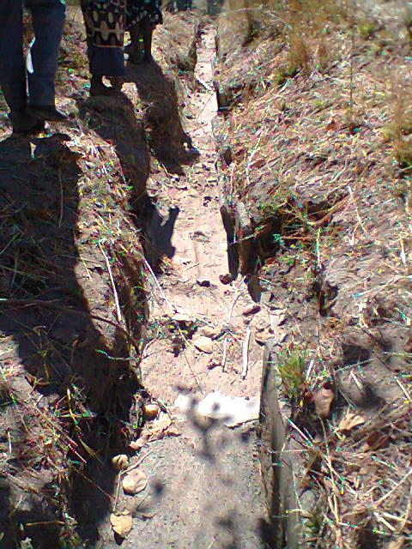
Fig 1: photo of the damaged conveyance canal which losses a lot of water during conveyance.

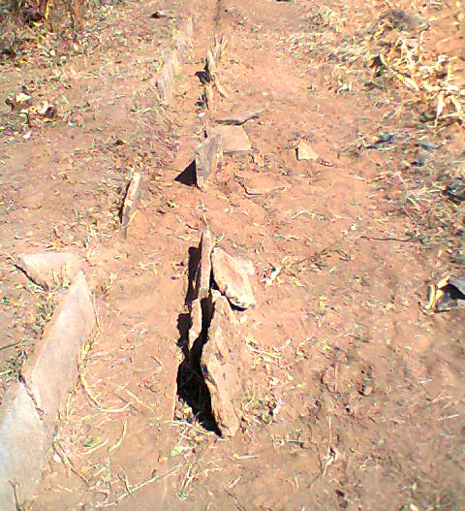
Fig 2: photo of damaged supply canal at Mutorahuku irrigation scheme which result in high water loss and shortages.

4.2 Water loss at infield tail end.
Table 2: Calculated infield canal tail end losses
Canal tail end no | Tail end water loss in m³/hr
1 | 1.240
2 | 1.312
3 | 1.300
4 | 1.880
5 | 0.992
6 | 0.920
Total | 7.644m³/hr for the measured canals

Table 3: Percentage water loss of measured canals
Canal | Design canal inlet discharge  m³/hr | Observed loss  m³/hr | % loss/hr
Canal 1 | 3.4 | 1.24 | 36.5
Canal 2 | 3.4 | 1.31 | 38.5
Canal 3 | 3.4 | 1.30 | 38.2
Canal 4 | 3.4 | 1.88 | 55.3
Canal 5 | 3.4 | 0.99 | 29.1
Canal 6 | 3.4 | 0.92 | 27.0

Figure 3: Canal tail end loses as a percentage of the inlet discharge
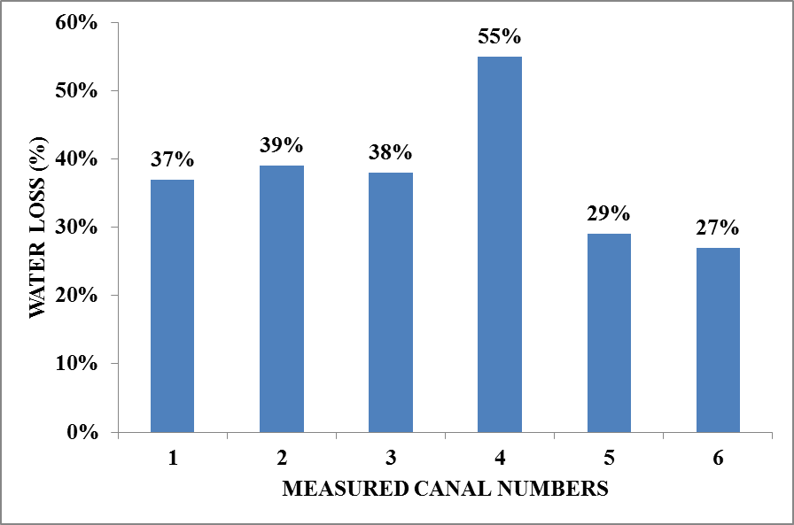

The percentage loses are all above the expected 10% loss of inlet discharge as recommended by FAO 2000) irrigation manual for surface design parameter. This shows that Mutorahuku is losing a lot of water during irrigation. From observations the reasons for these high loses was the number of siphons operating at a time was below the recommended. Farmers also use stones and mud to block water during irrigation because there are no suitable check plates or stoppers. There was no flexibility in reduce sluice valve discharge when few farmers were irrigating hence more water was lost as canal tail end loss.

Observed losses per infield canal in table 3 were further statistically compared with expected loss/ hr of surface irrigation infield canals using the FAOs parameter that 10 % of design discharges in an infield canal can be regarded as expected loss since infield canal efficiency is 90%. Design infield canal discharge is 3,4m³/hr hence 0,34m³/hr is the expected loss.
Table 4: T- test of the observed loss and the expected loss
One sample statistics
 | Test value 0,34
Observed loss | t | df | Siq(2 tailed) | Mean difference | 95% confidence interval of the difference
 |  |  |  |  | lower | upper
7.644 | 6,735 | 5 | .001 | .93367 | .5773 | 1.2900
.
The result showed that there is a difference between observed losses in table 3 and expected losses of 0.34m³/hr. Observed losses are greater than the expected losses hence the scheme is losing a lot of water as tail end losses. According to FAOs design parameter 5.4m³/hr can irrigate a hectare in the semi arid climate in dry season. This implies that this scheme can irrigate a hectare more than an extra hectare per hour with the observed 7.644m³/hr loss if good water management practices are employed.

4.3 Farmer Irrigation Practices Compared to Recommended Techniques
From questionnaires the following information about farmers irrigation practices against recommended irrigation techniques were determined. Figure 4 shows the percentages of farmers who practice the recommended techniques and those who defy the recommended techniques.
Figure 4: Farmer Irrigation Practices Compared to Recommended Techniques
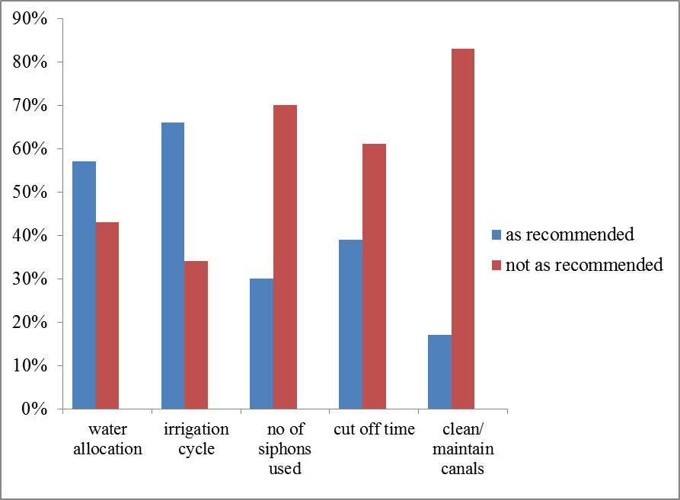

Water allocation; 57% of the interviewed scheme farmers get their water allocation as recommended thus they follow the irrigation schedule designed for the scheme. 43% would just irrigate whenever they have access to water for example they would come to the scheme early and would divert water to their plots even if they are not on schedule.
Irrigation cycle; 66% of farmers in the scheme follow their irrigation cycle. 34% of farmers would irrigate again before given their turn. If some farmers fail to irrigate on their schedule day they should wait till the two blocks have finished then they would irrigate on rest day. Their irrigation cycle is such that block A would irrigate on Tuesday then Wednesday block C then Thursday those who had failed to irrigate are given a chance to irrigate. Sunday and Monday are days to fill the night storage dam with water from the main dam. The two blocks would irrigate again on Friday and Saturday if the temperatures are hot.
Number or siphons used /furrow; 70% of interviewed farmers in the scheme use two or more siphons in one furrow. The 6mm diameter siphon that they use can release 3.36 l/sec at a head of 20cm (FAO, 2002). Using two or more siphons is not recommended since the pressure of water from the siphons would erode all the top soil of the furrow inlet. This would also wash away all nutrients at the inlet area resulting in poor yield at that side of the furrow. Due to increased pressure and soil erosion at that area a depression is also created resulting in an increased head to more than 20cm which is also not recommended. 30% of the farmers use one siphon /furrow as recommended. FAO also advised farmers not use a stream flow of more than 3.0 l/ sec and recommend 4mm or 5mm diameter siphons with a discharge of 1,49 l/sec or 2,33 l/sec respectively at 20cm head.
Cut off time; 39% in the scheme use the recommended ¾ rule irrigation technique during irrigation thus they cut off siphons when furrow stream flow 3 quarters of the full length of the canal. Thus if the recession phase takes 30 minutes then after 22,5 minutes the farmer should cut off the siphon. 61% of the farmers irrigate until water reaches the furrow end and flow to the drain then they would cut off siphons. This results in high furrow tail end losses.
Cleaning/ maintaining canals; 83% of interviewed farmers are not cleaning and maintaining their canals. Only 17 % adhere to the recommendation. Farmers are recommended to clean and maintain the canal that feeds their block as a whole and plot holders should also take care of that portion of the canal that he or she uses during irrigation. A plot holder is expected to maintain and clean the embankment of his/her portion. Embankment should be put to strengthen the slopping sides of the canal. Cleaning should be done so that no soil should be in the canal to promote growth of weeds in the canal. From observations and answers on the questionnaires it shows that farmers are not maintaining their canal as recommended since most farmers said they clean once a year. The canals also have cracks which farmers are expected to patch if they were maintaining. Most canals have no embankment hence canals can easily break if animals step on them.

4.4 Farmers adherence to recommended operation and maintenances and irrigation techniques
Figure 5; shows level of adherence to recommended operation and maintenance and irrigation techniques.
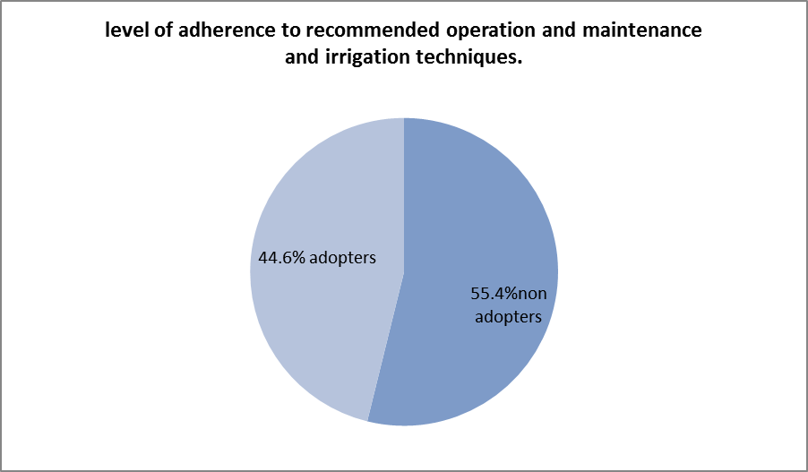

44.6 % of the farmers in the scheme have adopted the recommended irrigation water management techniques like number of siphons used per furrow, recommended cut off time, following irrigation cycle as well as cleaning and maintaining canals.55.4% still need assistance through training on irrigation water management since they still lack the knowledge on the recommended irrigation techniques.

4.5 Major problems contributing to water loss and shortages
Figure 6: Percentages of farmers who evidenced problems at the scheme.
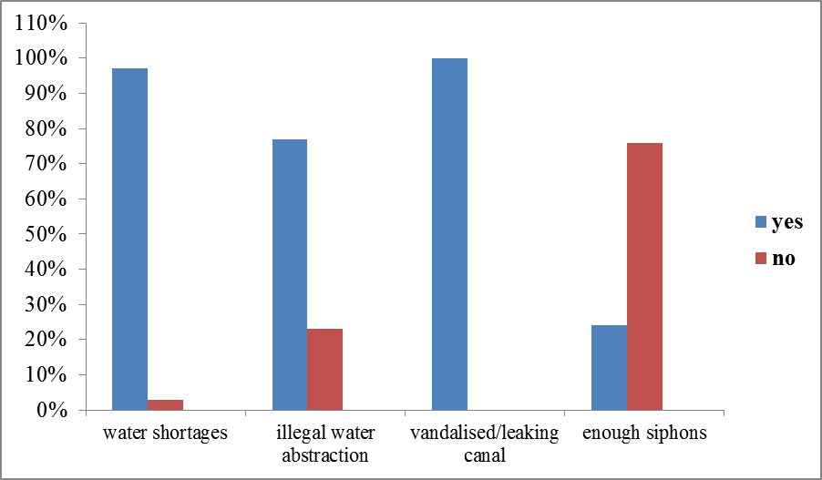
Water shortages; About 95% of the farmers said water is not adequate for them. Only 5% said there is no water shortage in the scheme.
Illegal water abstraction; 78% of the farmers in the scheme supported that there is illegal water obstruction by people settled along the conveyance canal. 22% said there is no illegal water obstruction along the canal.
Damaged and leaking canals; All scheme farmers supported that there are damaged and leaking canals in the scheme which is also leading to high water losses. They said the canals are old and had never been repaired since they were constructed. Most damaged canals are the supply and the conveyance canal.
Siphons; 76% of the surveyed farmers have no siphons and said they do not even have one hence they borrow from others if they want to irrigate. They said the siphons they have are old and now leaking and some are broken and become short to suck water. 24% have siphons.

CHAPTER 5
CONCLUSION AND RECOMMENDATIONS
5.1 Conclusion
The findings of the study showed that Mutorahuku Irrigation Scheme is losing a lot of water during conveyance.16.7m³ are lost during conveyance. From observations and discussions with farmers the conveyance has never been rehabilitated since 1967.
Canal tail end losses are also high due to farmer irrigation practices. Water being lost as canal tail ends can irrigate 1ha/hr more as recommended by FAOs design parameter that 5.4m³ / hour /hectare is required in semi arid climate during the dry season. Observed losses were up to 7.644m³/hr.
Farmer irrigation practices at Mutorahuku did not comply with the recommended techniques and contributed much to irrigation water loss and shortages. Mutorahuku IMC has no power to sue those who defy the rules and regulations of the scheme. Some people operating in the scheme are informal beneficiaries and do not even know the rules and regulations of the scheme. They are also not trained and would not attend meetings where information about the scheme is usually disseminated. They also do not participate in operation and maintenance of the scheme.
5.2 Recommendations
To reduce tail end loses farmers need training on recommended irrigation techniques.
There is need for awareness campaigns on the importance of water to be done in irrigation scheme.
There is need for monitoring farmers when they irrigate so as to ensure that they comply with recommended irrigation techniques and sluice gates should be adjusted to discharge less water if few farmers are irrigating.
Farmers on schedule/ infield canal should irrigate at the same time so as to effectively use water and reduce canal tail end water loss.
The IMC should be given powers to sue irrigators who defy rules and regulations in irrigation scheme.
IMC should enforce all rules and regulations in the scheme. All informal farmers in the scheme should be registered and trained if they wish to continue farming in the scheme.
The availability of water use information to water users is also of paramount importance to the success of water management (Zimcosult, 2002). Farmers should know how much water they have used and charges attached to it so as to measure viability of their project since water charges also contribute to their production cost.
5.3 Areas of further research
Impact of seepage loss, livestock consumption and illegal water abstraction in conveyance to water shortages in surface irrigation.
Effects of illegal irrigation water abstraction from conveyance to water management in the scheme.
Implications of informal irrigators in water management and operation and maintenance of smallholder irrigation schemes.

REFERENCES
FAO (2000) Socio-economic impact of smallholder irrigation in Zimbabwe, Case
studies of ten irrigation schemes, FAO SAFR, Harare.
FAO (2001).International e-mail Conference on Irrigation Management Transfer. INPIM/FAO, FAO Land and Water Digital Media Series
FAO, (2002) Irrigation Manual, Planning, Development, Monitoring & Evaluation of Irrigated Agriculture with Farmer Participation, FAO, Harare.
Gumbo. D. (2006)Working Together to Respond to Climate Change, Annex I Expert Group Seminar in Conjunction with the OECD Global Forum on Sustainable Development Zimbabwe, Country Case Study on Domestic Policy Frameworks for Adaptation in the Water Sector, WWF- Southern Africa.
Hill, R.W. Patterson, R. Barnhill, J.V. (2008) Small Acreage Irrigation System Operation and Maintenance, Logan, Utah State University.
Hoekstra, A.Y. and Chapagain.A.K. (2007) Water footprints of nations, Water use by people as a function of their consumption pattern, Water Resource, Manage.
Melvyn, K. (2001) Smallholder Irrigation Technology, Prospects for Sub-Saharan Africa Technology & Engineering FAO.
Motsi, K. E. Zirebwa, J. and Machingambi, L. (2001) Assessment of the smallholder irrigation performance: Management of conveyance and distribution infrastructure at Murara and Nyamatanda north-east of Zimbabwe, Journal of Applied Science in Southern Africa 7 (1). 9-22
Ndamba. J. Sakupwanya.J.S.Makadho. J and Manamike P. (no date) A study to determine water demand management in Southern Africa. The Zimbabwe Experiance. Institute of Water and Sanitation Development.
Ngaira. J. K (2002) Challenges of Water Resources Management and food production in a Changing Climate in Kenya. Journal of Geography and regional Planning.Kenya.
Pazvakavambwa, G. T. and Van Der Zaag, P. (2000).The value of irrigation water in Nyanyadzi smallholder irrigation scheme, Zimbabwe, Paper presented at the 1stWARFSA/Water Net Symposium, Sustainable use of water resources, Maputo, 1-2 November 2000, Maputo.

Samakande, I. (2000) Improving the performance of smallholder surface irrigated
Schemes, pp 151-158, In Manzungu E. (Ed.) The processes and dynamics of catchment management in Zimbabwe, Save Africa Trust Publications, Harare.
Senzanje A, Samakande I, Chidenga, Magutso E, 2003, Field irrigation practice and the performance of smallholder irrigation in Zimbabwe, Case of Chakohwa and Mpudzi Irrigation Scheme.
Sithole P N (2000). The Impact of Smallholder Irrigation on Household
Food Security in Marginal Areas.
Vital Water Graphics. (2008) An Overview of the State of the World’s Fresh and
Marine Waters, 2nd Edition.
Walker, W.R. (2003) Surface Irrigation Simulation Evaluation and Design, Logan, Utah State University.
Zimcosult (2003) Water pricing options and implications, Final Report Prepared for the Steering group of the Water Resources Management Strategy, Zimbabwe.

APPENDIX 1
Recordings for time taken to fill a collecting bucket used to calculate conveyance losses.
Inflow
Measurements were taken 5 times and the average time was used.
measurement time (sec)
1st 1.5
2nd 1.4
3rd 1.4
4th 1.6
5th 1.6
Average 1.5sec to fill a 20l bucket

Outflow
Measurement time (sec)
1st 2.3
2nd 2.4
3rd 2.4
4th 2.3
5th 2.1
Average 2.3 sec to fill a 20l bucket

APPENDIX 2
Water loss measurement at infield canal tail end
Measurements were taken 5 times at different times for one tail end and the average was used as time taken to fill a 20l bucket of water. The number of siphons operating during measuring was also recorded.
Block C | NO of siphons | Time(sec) | Average time (sec) to fill 20l bucket
Tail end 1 | 15 | 58.55 59.01 58.49 57.08 57.81 | 58.19
Tail end 2 | 8 | 56.08 54.18 52.21 56.3256.12 | 54.89
Tail end 3 | 6 | 56.81 53.48 55.61 53.4856.61 | 55.2
Block A
Tail end 4 | 12 | 38.81 36.50 37.47 41.0840.40 | 38.85
Tail end 5 | 10 | 82 80 81 82 81 | 81
Tail end 6 | 8 | 90 91 93 90 90 | 91

APPENDIX 3
QUESTIONNAIRE B
NAME OF FARMER ……………………………………..
Date………………
Plot No……………. Size of plot…………………..
Crops grown…………………………………………………………………………………
1 How is water allocated to you? Upon request / follow irrigation cycle.
………………………………………………………………………………………………
2 How do you decide when to irrigate? As per schedule/whenever there is access to water.
………………………………………………………………………………………………
3 After an irrigation event how long do you wait before irrigating again? Give crop name and the cycle.
……………………………………………………………………………………………….
……………………………………………………………………………………………………………………………………………………………………………………………………
4 How many siphons do you put per furrow when irrigating and how many furrows do you irrigate at a time?
………………………………………………………………………………………………
5 How long is each siphon left discharging water into a furrow when irrigating?
…………………………………………………………………………………………….....
6 Do you sometimes experience water shortage and what are the causes of water shortages?
………………………………………………………………………………………………
………………………………………………………………………………………………
7Are there any illegal water abstractions along the conveyance canal and what is the water used for?
……………………………………………………………………………………………………………………………………………………………………………………………………..
8 Are there any vandalized or leaking areas along the canals and what are the causes of that?
…………………………………………………………………………………………………………………………………………………………………………………………………..
9 How often do you clean and maintain your canal furrows and drains?
………………………………………………………………………………………………
………………………………………………………………………………………………
10 How much do you contribute per month for water bills?
................................................................................................................................................
11 What challenges do you face when irrigating which makes your activity difficult?
…………………………………………………………………………………………………………………………………………………………………………………………………….
SIGNATURE…………………………

